**5. Microservices Architecture and Design**

Shivakumar R Goniwada[**1**](https://learning.oreilly.com/library/view/cloud-native-architecture/9781484272268/html/511610_1_En_5_Chapter.xhtml#Aff2)

(1)

Bangalore, India

Microservices are an architectural style for developing a single application as a set of domain services. Each service runs its process. The services communicate with clients and other services through synchronous and asynchronous protocols.

The microservices are highly maintainable, testable, loosely coupled, independently deployable, organized around business capabilities, and most important owned by a small team. This enables the rapid, frequent, and reliable delivery of large, complex applications. It also enables an organization to evolve its technology stack.

While much of the discussion about microservices has revolved around architectural definition and characteristics, their value can be more commonly understood through fairly simple business and organizational benefits: code can be updated more easily, and new features or functionality can be added without touching the entire application. This enables IT to develop and roll out new digital offerings more quickly and faster, making microservices an obvious choice for a cloud native application.

This chapter provides insight into implementing a microservices architecture for those who already have an idea of software architecture, design, and development. There are plenty of books and whitepapers available on microservices, and I will not duplicate that information; instead, I am covering microservices in the context of cloud native and showing some real implementations and problems you may face during implementation.

In this chapter, I will cover the following topics:

* Microservices architecture, the implementation and characteristics
* Decoupling
* How APIs are the de facto choice for microservices
* Hexagonal architecture and how to implement it
* Reactive architecture and how to implement reactive microservices
* Resilience and fault tolerance in microservices
* Misconception of microservices
* Using AI and ML in microservices
* Case studies with real-time examples

**Evolution of Microservices**

Eric Evans wrote a book about domain-driven design (DDD) on how to modularize domains. This helped us to think about architecture, design, and code from a domain/business angle instead of just an IT angle. The concept of continuous integration showed us how we can automate our development and delivery process and efficiently move code to the production environment. We used to think that layering was the only approach for software development, but Alistair Cockburn’s concept of hexagonal architecture changed the way we think of software architecture. The evolution of infrastructure from VMs to LXC containers to Docker containers helped us to better manage infrastructure. Martin Fowler and his team helped us to deliver software snippets by using agility.

DDD, agility, containers, DevOps, cloud, the microservices evolved from this world. No one invented microservices, but they emerged from the trends for solving business problems. Martin Fowler and his team from ThoughtWorks, Netflix, and Amazon helped us to build microservices. I started defining microservices in 2013, and I first developed a gaming client with the help of the former ThoughtWorks team.

In this chapter, I will explain a few important details of microservices for cloud native architecture and show some examples.

**What Is a Microservices Architecture?**

A microservices architecture, as shown in Figure [5-1](https://learning.oreilly.com/library/view/cloud-native-architecture/9781484272268/html/511610_1_En_5_Chapter.xhtml#Fig1), is an approach to developing one business application as a suite of domain services, with each domain service running on its container and communicating with a lightweight mechanism in a synchronous or asynchronous manner by using HTTP, GRPC, or messaging. These domain services are developed around business capabilities using independently deployable but fully automated deployment tools. Each domain service is decentralized in nature and developed with the polylithic and polyglot principles in mind.

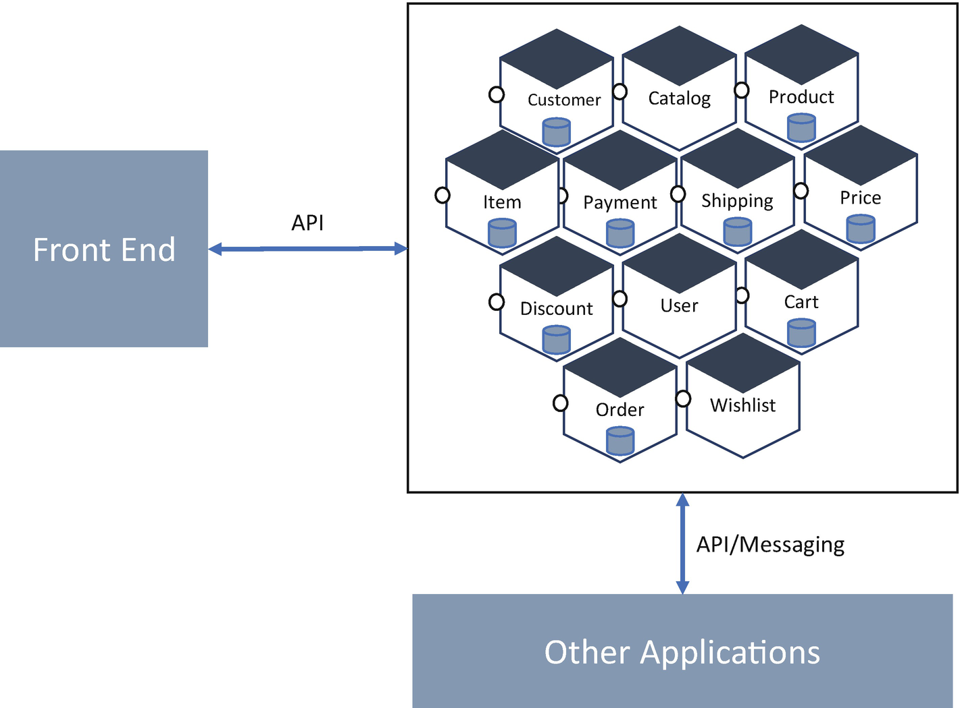

***Figure 5-1***

Cluster of microservices

Microservices can be adopted for any size and any type of business application irrespective of industry. Microservices are domain-based but have their unique characteristics. When you are considering building microservices, you need to make sure the following characteristics apply. Without these characteristics, whatever you are building is not a microservice; instead, you are building just a small monolithic application.

**Characteristics of Microservices**

The following are the characteristics of microservices.

**Organized Around Business Capabilities**

Before you start designing any microservices application, identifying and defining each microservice is important. What is the boundary of the microservice? What domain should it contain? What are the events and commands? What is the user role? Where will my microservices be deployed?

In a traditional application development, as shown in Figure [5-2](https://learning.oreilly.com/library/view/cloud-native-architecture/9781484272268/html/511610_1_En_5_Chapter.xhtml#Fig2), we designed around the technological capabilities such as the user interface, databases, business logic, data access objects, etc., but we never had any discussion about the domain or contract or boundary.

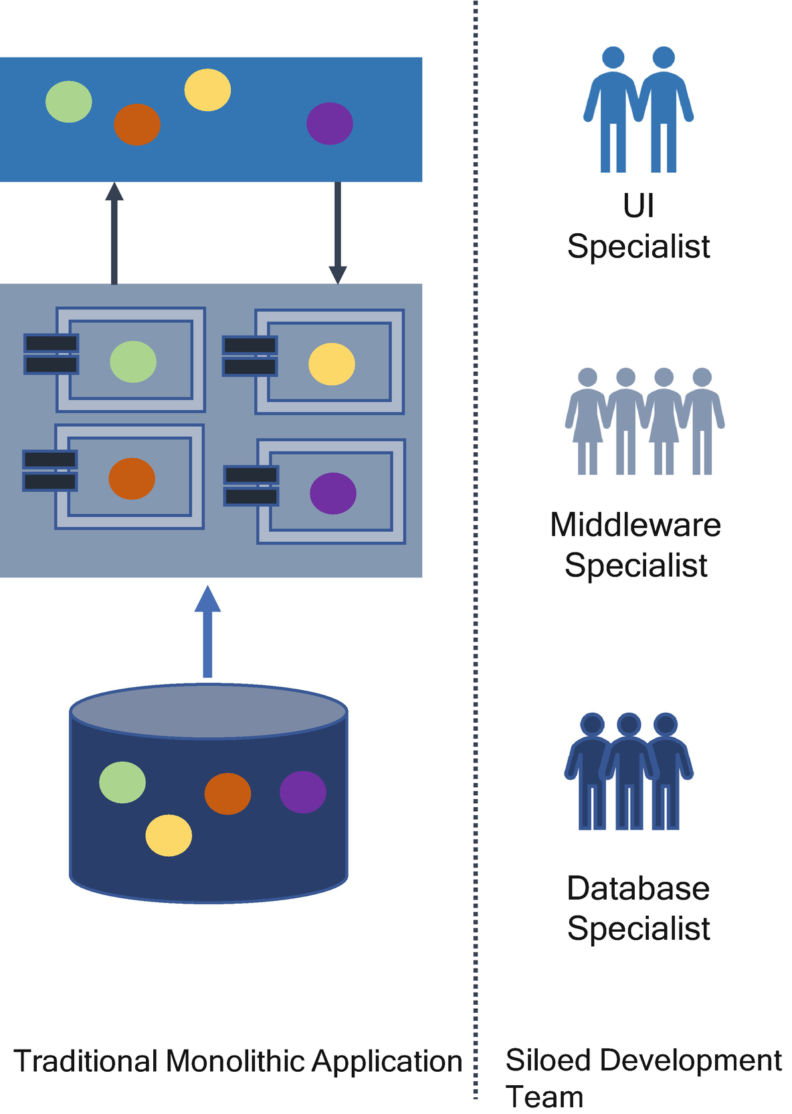

***Figure 5-2***

Traditional architecture

In a microservices development, as shown in Figure [5-3](https://learning.oreilly.com/library/view/cloud-native-architecture/9781484272268/html/511610_1_En_5_Chapter.xhtml#Fig3), each team owns the lifecycle of its services to production. Small teams act autonomously and are decentralized to build and own the microservices in production. This is called an *agile pod culture*. The structure includes all the resource capabilities to own and covers all the inception, construction, and operation-related microservices. This is the way that Amazon, Netflix, and Google are organized.

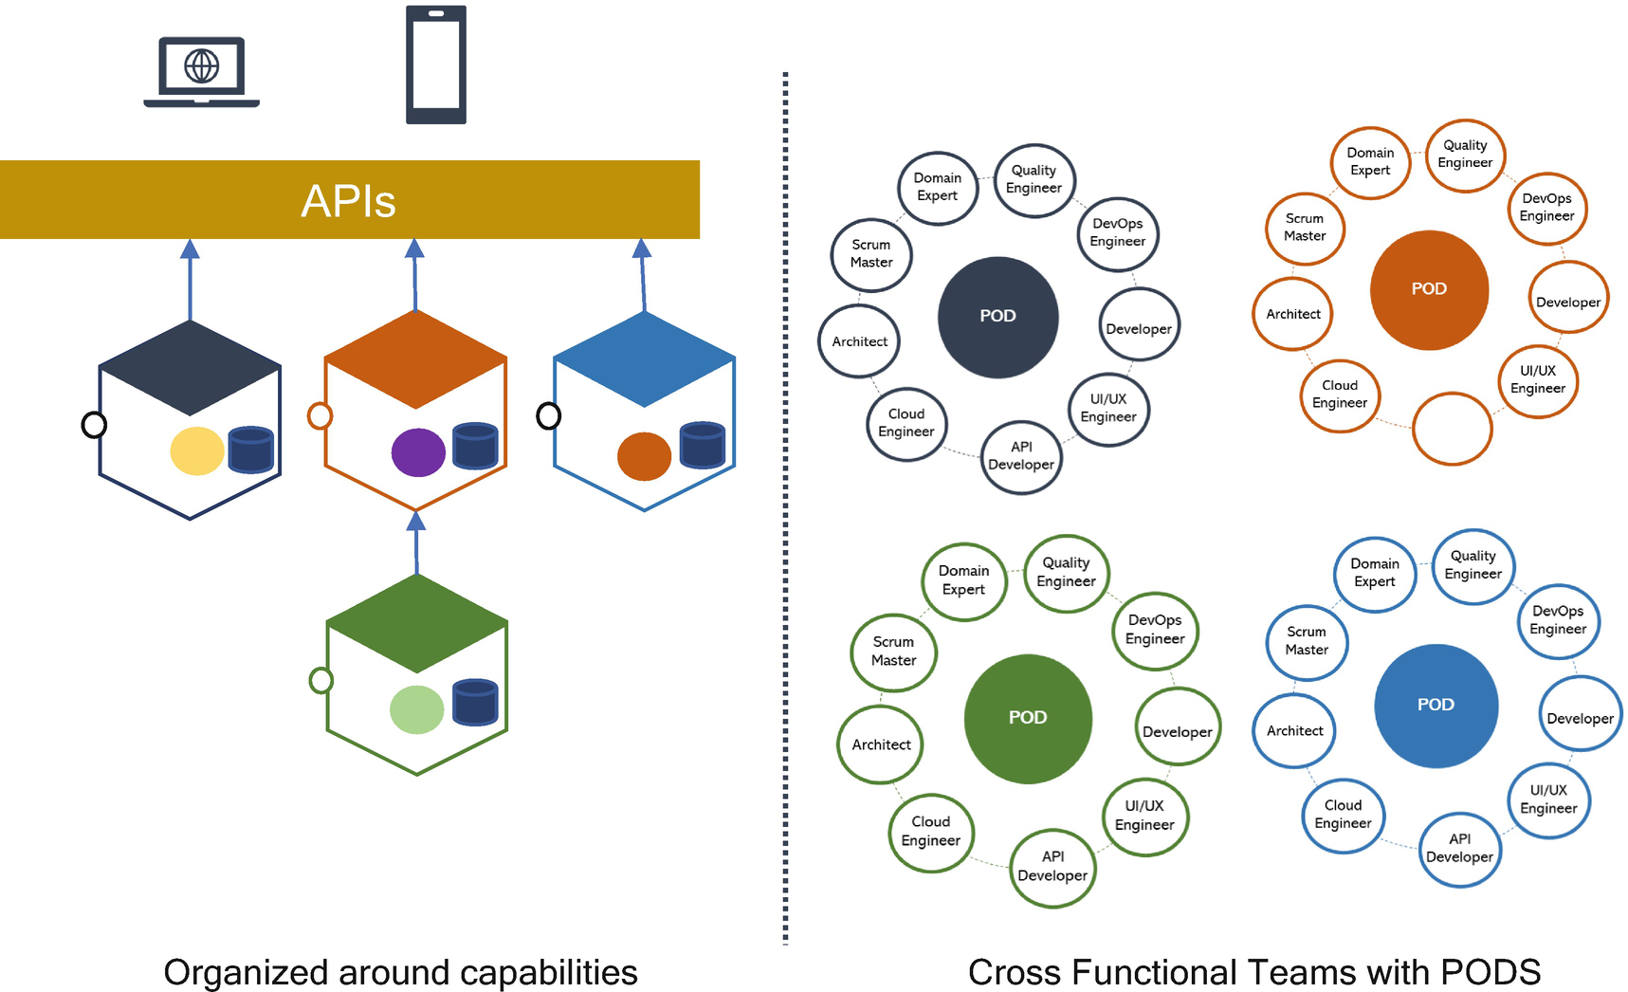

***Figure 5-3***

Microservices architecture definition

When the architecture and capabilities are organized around domain business functions, the dependencies between the components are loosely coupled. As long as there is a contract between services, then each pod can run at its own speed. The structure of the agile pod was influenced by Conway’s law.

Specifically, Melvin Conway mentioned the following in his book:

*“Organizations which design systems are constrained to produce designs which are copies of the communication structures of these organizations.”*

The meaning of this law is that communication is the key across teams; the teams belong to capabilities that require communication and collaboration to build an effective software system. If we work in silos like in a traditional development, there is no visibility across other teams. What they are doing, and how they are doing it? All these teams depend on well-structured documentation that consumes a lot of time, and there is no accountability and responsibility in teams. At the end, projects face too much technical debt and too many quality issues.

To overcome this problem, modern-day architecture follows Conway’s law with a pod culture. The agile pod is designed as per the software deliverables, involving varying levels of roles such as the scrum master, developers, QA, architects, API experts, UI/UX designers, etc. These teams are customizable and may change depending on the current requirements. Each pod team owns an end-to-end microservices lifecycle, which helps to fix the accountability and ownership in an enterprise and also eases communication and optimizes the delivery time.

This means that business domains can drive development decisions; organizing around capabilities means that each microservices team owns the function and data completely.

You need to consider the following factors when you are organized around business capabilities:

* *Process*: Execute the app as one or more stateless processes. This means each microservices owns only one domain function and solves only one problem.
* *Codebase*: Have one codebase tracked in revision control and many deploys. This means each microservice uses separate repositories.
* *Build, release, run*: A codebase is transformed into a deploy through build, release, and run stages. This means each microservices has its own DevSecOps pipeline.
* *Admin process*: Run admin/management tasks as a one-off process; this means each microservices has its administrative tasks.
* *Config*: Store the config in the environment; this means each microservices has its containers, and it stores the config in a sidecar.
* *Disposability*: Maximize robustness with fast startup and graceful shutdown, which means each microservices is independent and has its lifecycle without affecting other services.

**Autonomous**

Microservices are a self-contained unit of functionality with loosely coupled dependencies across other services. The services are separate entities and deployed in an isolated container environment. All communication between microservices is through network calls by using HTTP, GRPC, and messaging protocols to enforce separation between the services.

These microservices can change independently and are deployed by themselves without requiring the consumer or other services to change, except for service contracts between consumer and other services. To create more autonomy in your microservices, you need to think about what services should be exposed and what they should have hidden. If there is too much sharing, our consuming services become coupled to our internal representations. This decreases your autonomy, as it requires additional coordination with consumers when making changes.

When you are adopting autonomous and DevSecOps in microservices, you need to consider the following design principles:

* *Communication independence*: Microservices constrains intraservice communication with other microservices as well as how your microservices communicate with external consumers. You must use nonblocking for all interservices communications. HTTP or the GRPC protocol is an example of blocking, and messaging is an example of a nonblocking technology; in addition, you should not consider using an external load balancer for interservice communication. All external communication negotiates its initial connection with API gateways for unified access control, and all subsequent communication is based on point-to-point communication with microservices and uses a round-robin load balancer to achieve equal distribution of load across microservices.
* *Agnostics*: The agnostic in your design dictates what should be provided by microservices. A pod team should be able to confer with the consumers of their service to determine what the contract should be and deploy it with no architecture configuration required and no concept of where and how the services are run.
* *Scalability*: The scalability principle governs rules for services configuration and implementation to ensure that the architecture is decentralized as much as possible and to ensure linear scalability. Microservices should not be aware of anything about other services’ existence and their scalability. This means that any coordination of communication cannot be controlled above the service scope.
* *Independence*: All microservices are based on acting on incoming data and then responding to that by publishing their data. All services are equal; there is no master-slave concept. All services are terminated by themselves and not influenced by any other services.

**Smart Endpoints and Dumb Pipes**

This section discusses how your microservices effectively communicate with each other and what mechanisms need to be used. Communication across microservices is not an issue if you have only a few sets of microservices in your organization, but it becomes more complex when the microservices implementation grows in your organization.

If you go back to the SOA and ESB age, you used to implement services with BPEL or orchestration by central tool or process. The ESB is used to manage orchestration mechanisms to connect with various services or heterogeneous systems for intercommunication and managing logic. Now, with cloud native, there is no central tool, and we are not supposed to use one. The microservices are autonomous, decentralized, and distributed in nature; therefore, you need some kind of similar ESB mechanism in the microservices.

The alternative approach for an ESB-like mechanism in the microservices world is a smart endpoints and dumb pipes mechanism. The smart endpoints and dumb pipes simplify communication across microservices. In microservices communication, we use two types of protocols: synchronous and asynchronous with request/response and publish/subscribe, respectively.

The communication mechanism, security, and governance are often custom-coded into the microservice logic. Teams build in different languages and deploy to multiple environments, and organization services are typically siloed with a decentralized approach.

There are different approaches to solve communication complexity in microservices in which the endpoints are applications and the pipes are what connect them and allow them to communicate with each other. The following approaches are available:

* The first approach is to create custom code in the microservices logic as smart endpoints and use HTTP or message queues as dumb pipes. The drawback of this implementation is that you need to manage the code, implementation, and collaboration across various decentralized teams.
* The second approach is to create smart pipes like ESB. This is an anti-pattern. Microservices solve this anti-pattern. We are not suggesting that you implement this approach.
* The third approach is to externalize a communication mechanism to the sidecar proxy. In this case, the microservices concentrate only on the business implementation, letting the sidecar proxy manage communication at the network level. The drawback of this approach is you need to write custom configurations to manage communication across services by using sidecars.
* The fourth approach is an extension of the third approach. Use a service mesh and event mesh to communicate across services by using a sidecar proxy.
* The fifth approach is to use orchestration logic or software to simplify communication between microservices. Tools like Netflix Conductor or Uber or Zeebe, etc., provide an implementation of the orchestration mechanism. The drawback of these implementations is the single point of failure, and orchestration becomes too complex as microservices grow in an organization. This type of implementation is good for use cases like long-running services that are not best suited for choreography.

I suggest using the third and fourth approaches for implementing smart endpoints and dumb pipes, but the fourth approach is a clean implementation. This helps you to externalize the communication complexity and concentrate on the business logic.

**What Is a Service Mesh?**

In cloud native environment, a designing scalable and, independently deployable services are very much required. Services have grown largely in an organization, which creates a problem in the mesh of service-to-service remote procedure calls (RPCs) transported over networks. A service mesh helps you to design streamlined communication.

Service meshes provide intent-based networking for microservices and describe the desired behavior of the network topology. The service mesh pattern is used for microservices deployments and uses a sidecar proxy to enable secure, fast, and reliable service-to-service communications.

The service mesh provides the following:

* Provides a services-first network
* Removes the infrastructure concerns in the application code
* Provides declarative-based network behavior, node identity, and traffic flow through policy

**Smart Endpoints and Dumb Pipes with Service Meshes**

Using this approach, microservices deployed in a cluster interact with each other through a sidecar proxy, as shown in Figure [5-4](https://learning.oreilly.com/library/view/cloud-native-architecture/9781484272268/html/511610_1_En_5_Chapter.xhtml#Fig4). The sidecar intercepts both the synchronous and asynchronous communications of each service and acts according to the security and communication rules.

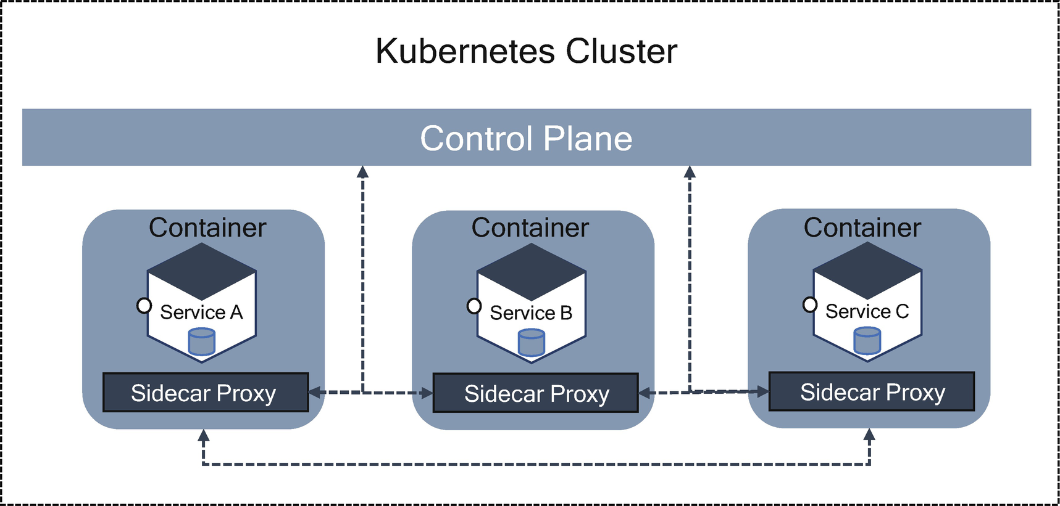

***Figure 5-4***

Smart points and dumb pipes in a service mesh

You can configure communication policies such as a circuit breaker, load balancing, service discovery, and security at the control plane level and abstract the governance considerations behind microservices from the service code.

A service mesh is used to abstract the governance regardless of the technology you are using to build microservices, and a service mesh is independent of the microservices architecture.

**What Is an Event Mesh?**

An event mesh handles the asynchronous event-driven routing of information between microservices. It intelligently routes events between the event brokers allowing the cluster or brokers to appear as a single virtual event broker.

A cloud native modern enterprise embraces an event architecture, and every application requires a robust central system to move events quickly, reliably, and securely from publisher to subscriber.

An event mesh is an architectural layer that dynamically routes events from one microservice to another irrespective of deployment location. The event mesh is a key enabler for event-driven architecture. An event mesh is a dynamic infrastructure that propagates events across disparate cloud platforms and performs protocol translation. You can find more details in Chapter [6](https://learning.oreilly.com/library/view/cloud-native-architecture/9781484272268/html/511610_1_En_6_Chapter.xhtml).

**Resilience in Microservices**

Being *resilient* is the ability to provide the required capabilities in the face of adversity.

Specifically, it is the ability of a solution to absorb the impact of a problem in one or more parts of services while continuing to provide an acceptable service level to the business. A resilient application must thrive even when the unexpected happens; in other words, it provides the required capabilities despite excessive stresses that can cause disruptions. The residual defects in the software or hardware will eventually cause the system to fail to correctly perform a required function or cause it to fail to meet one or more quality attributes of microservices such as availability, security, performance, reliability, usability, etc. An unknown or uncorrected security vulnerability will enable an attacker to compromise the system.

Microservices resilience is more complex, and no microservice is 100 percent resilient to all adverse events or conditions. Resiliency is always a matter of degrees. Resiliency in microservices is typically not measurable on a single ordinal scale; in other words, you cannot say service A is more resilient than service B.

Resilience is not one component activity within microservices. The resilience must be composed of its parts. To exhibit resiliency, microservices must incorporate controls that detect a vulnerability and respond appropriately to these disturbances.

The service should be intelligent enough to detect changing conditions and act before it fails. Even if it fails, the service must self-heal by taking corrective action to ensure the availability of services at all time. Services must learn from past failures to predict eventualities and act to avoid cascading failures.

**Resilience Capabilities**

A resilient microservice protects its key capabilities from harm by using protective resilience techniques to resist adverse events and conditions or actively detect these adversaries, respond to adversaries, and recover from the harm they cause.

The following are the common adverse effects that require the resilient applications:

* Load-related failures
* Age-related failures
* Network failures
* Lost communications
* Input errors and defect-related failures
* Cyberattack
* Kinetic attack
* Nonavailability of dependency services

Figure [5-5](https://learning.oreilly.com/library/view/cloud-native-architecture/9781484272268/html/511610_1_En_5_Chapter.xhtml#Fig5) shows how these adverse effects impact a microservice’s capabilities over some time. This scenario was captured for two microservices over a period of three days.

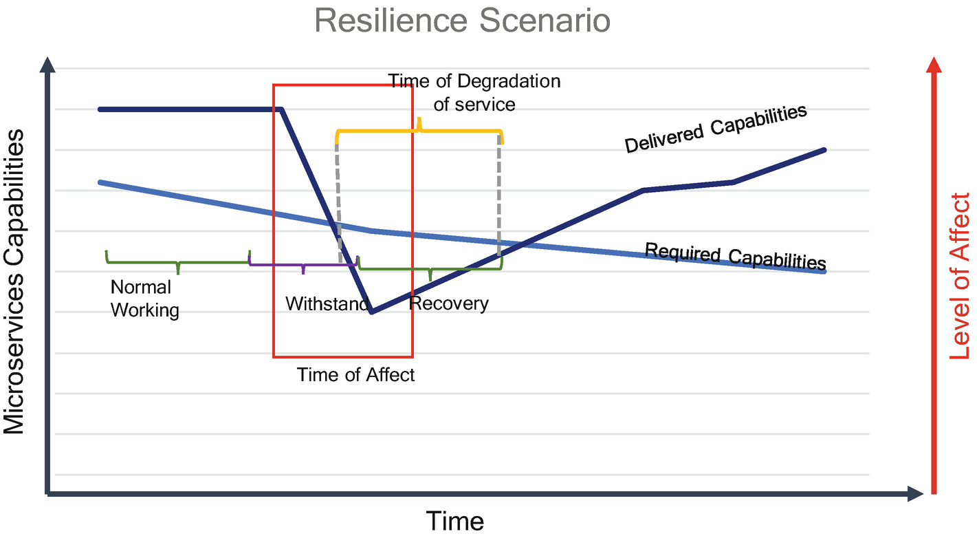

***Figure 5-5***

Resilience scenario

In the y-axis are microservices capabilities, and the x-axis is time. In the first few hours, the microservice performed with normal operation, and there were no adverse events. As time progressed and load increased, an adverse event occurred, and the microservices are encountered a fault and degraded the operation. This degradation exists for a certain time until response controls mitigate the faulty operation, and then the microservice will be in the normal working condition.

**How to Build Resilient Microservices?**

How do you design for automatic self-healing and application resiliency? As mentioned, with enough services and loads on the system, the microservices will always be in a partial failure status. But how can a designer approach microservices resilience? Approaching for resilience is not a one-time activity but is a continuous plan, culture, and work during the entire lifecycle of microservices.

The following patterns help you to design resiliency in microservices:

* **Circuit Breaker Pattern**
* The circuit breaker pattern prevents further damage to a failing system. The circuit breaker pattern detects the problem in the downstream system from timeouts and errors returned from the system. You can learn more details of the circuit breaker in Chapter [4](https://learning.oreilly.com/library/view/cloud-native-architecture/9781484272268/html/511610_1_En_4_Chapter.xhtml).
* **Bulkhead Pattern**
* When designing your microservices application, sometimes you overload specific services within the application, and too much overloading leads to degrading of the service performance. This pattern isolates services and consumers via partitions. Learn more in Chapter [4](https://learning.oreilly.com/library/view/cloud-native-architecture/9781484272268/html/511610_1_En_4_Chapter.xhtml).
* **Stateless Services**
* Use stateless services for designing resilient microservices. Stateless services depend on inputs and don’t hold data; any copy of this service serves similar activity as the original services. These services spin off instantly depending on the condition of services such as CPU, load, etc. The load balancer can distribute load across microservice instances to improve resiliency and availability, and the load balancer can route based on the availability of instances.
* **Retry**
* Use the Retry option in your services; sometimes failures are short-lived for a few milliseconds, so retrying a few times may help in getting a response from the services. You can find more details in Chapter [4](https://learning.oreilly.com/library/view/cloud-native-architecture/9781484272268/html/511610_1_En_4_Chapter.xhtml).
* **Fail Fast**
* Slow failure responses are the worst; it is better to have no response than a slow response. Implement self-restart by using the monitoring data. Use the container restart principle to autorestart your services. Learn more about how to restart a service in Chapter [3](https://learning.oreilly.com/library/view/cloud-native-architecture/9781484272268/html/511610_1_En_3_Chapter.xhtml). Verify your service integration points early for downstream applications and other resources and send a validation request before processing.
* **Timeout**
* Use this pattern to design resilient microservices. When a consumer requests your services, there could be many reasons that your services might not respond or slow response. If there are too many requests during this period of slowness, this can cause a cascading impact, bringing the entire system down. Configuring connections and read timeouts at the client helps to release resources to the pool in case the microservices or database is taking more time than usual.
* **Throttling**
* Use this pattern for resilient microservices. The throttling or rate-limiting technique limits the number of incoming requests to be processed within a given time window. This approach helps to control the throughput meeting the SLAs and conserves the resource utilization by accepting only as many requests as it can handle.

There are various tools and software available to manage resiliency in microservices. Hystrix is a library designed by Netflix to isolate points of access to remote systems, services, and third-party libraries; stop cascading failures; and enable resilience in a complex distributed system where failures are inevitable.

Resilience4J was designed for functional programming; use this tool for managing resilience.

**Elasticity in Microservices**

Microservices and containers in a production environment need the adaptation of processes to enable elasticity. In a cloud native architecture, the microservices might receive unpredictable workloads and need to respond quickly to match the load and guarantee the quality objectives.

One of the most important characteristics of the cloud is elasticity. This is the degree to which a system can adapt to changes in demand by provisioning and releasing resources autonomously by autoscaling.

The following are the best practices you need to adopt for elasticity in microservices:

* Microservices must be stateless, and the states of an application must be stored outside of a container. The stateful application requires more care because a stateful data store will need to shard, replicate, and scale its state across the members in the cluster and know how to rebalance itself during scaling events.
* To keep costs to a minimum and meet quality objectives with agreed-upon service level objectives (SLOs), you need to configure the Kubernetes cluster to alter the required containers based on demand.
* For an event-driven architecture, each container instance is attached as a listener to the same request queue where the request arrived for processing. Use predictive approaches to set the arrival rate of the requests so that provisioning and releasing of resources take place beforehand. Here you need to add queues to the monitoring; you can configure the scale-up and down of resources based on the load on the queues.

Figure [5-6](https://learning.oreilly.com/library/view/cloud-native-architecture/9781484272268/html/511610_1_En_5_Chapter.xhtml#Fig6) illustrates how elasticity can be achieved in containerized microservices. I am using a payment processing example to show the elasticity. This example was captured during the first week of a month.

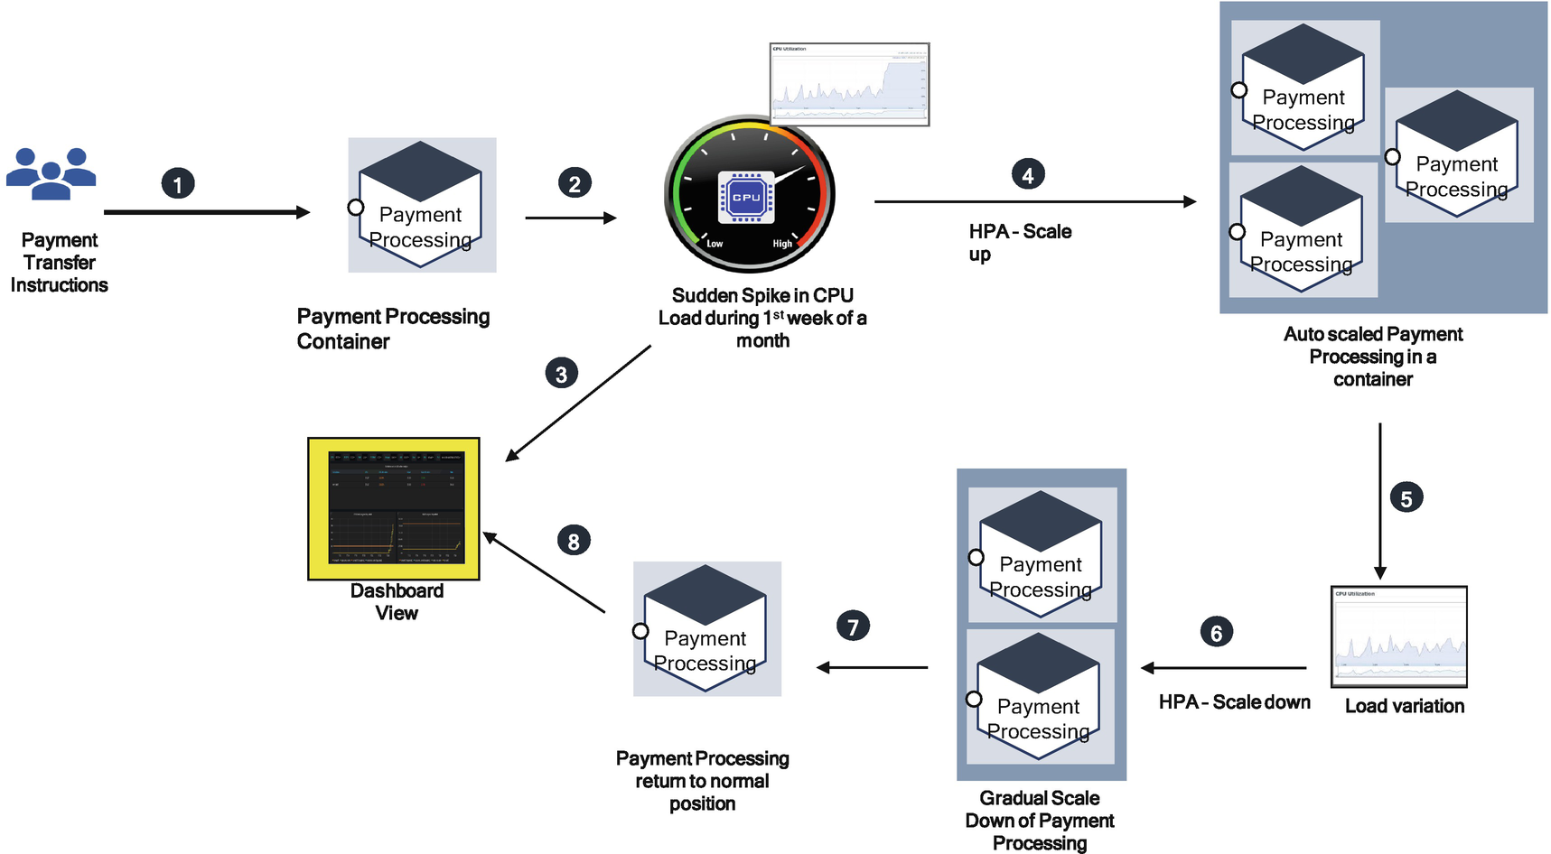

***Figure 5-6***

Elasticity in payment processing

More requests are always initiated during the first week of a month because the customer needs to use services for loan payment, payment of utility bills, etc. To meet the SLOs and quality attributes of microservices, the containers need to scale up and down based on the CPU load. When a spike occurs in payment services, the autoscaling option triggers and creates more instances of containers and scales down as CPU load decreases.

**Distributed State**

The state needs to exist within a bounded context of microservices. This is an ideal situation in a cloud native architecture.

In a distributed state across many microservices, it is difficult to say data is complete; only messages are being passed back and forth to create the whole transaction.

Let’s see an example of collateral management in the capital market, as shown in Figure [5-7](https://learning.oreilly.com/library/view/cloud-native-architecture/9781484272268/html/511610_1_En_5_Chapter.xhtml#Fig7). It shows three bounded context microservices: Exposure Validation & Matching, Exposure Lifecycle, and Exposure Settlement. (Exposure is the entry point into the collateralization functions of multiple parties.)

All three microservices have different responsibilities. The responsibility of the Exposure Validation & Matching microservice is to validate all the business fields received from both APIs and event messaging, and it needs to match against other party exposures. Exposure Lifecycle’s purpose is to manage all the exposures received from both APIs and event messages until the full settlements, and the Exposure Settlement microservice settles the collateral to other parties.

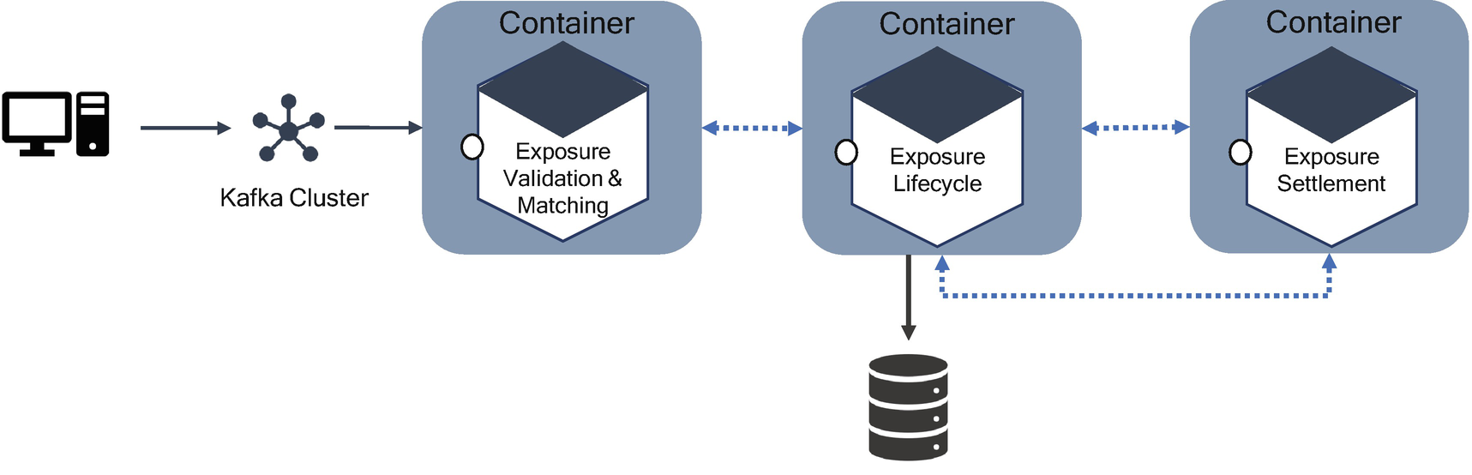

***Figure 5-7***

State management

In the classic SOA with ESB architecture, you might see the exposure is the common item and attempt to make it shared among these three microservices. This leads to functional bottlenecks. In fact, with these three examples of microservices, the only shared fields are the exposure business function. All the fields are unique to each microservice.

The state change of these microservices may be the result of many different inputs, and the inputs may come from other microservices with very low latency. The speed and scale at which the state is changing may make managing this with some sort of synchronous API call seem overwhelming. Changes to the state may be relevant and not just to the result. Synchronous API endpoints are not well suited for this type of change.

To manage various collateral types that are coming from different exposure services, the collateral management application is to keep track of changes in collateral in an ordered way, without having to lock or pause any other services. Everything must be asynchronous. Given these constraints, a service may need to retrieve the state as a whole.

**How to Handle Distributed State with Asynchronous microservices**

Nondistributed state is not an issue; it has one centralized, canonical representation of state. The state is accessible; you can manage the state without much complication. Distributed state is not easy because it has many dark corners, making it tricky.

In a distributed state, nothing is complete; only messages are passed between the services. These messages arrive out of order, are partially delayed, etc. You must consider failures when you are working with distributed systems.

As I explained in Figure [5-7](https://learning.oreilly.com/library/view/cloud-native-architecture/9781484272268/html/511610_1_En_5_Chapter.xhtml#Fig7), state change may be the result of many different inputs, and inputs might be user activity or other services. For either of these inputs, users are making relatively slow state changes or in a few service processes making high-frequency changes, so the state will be constantly moving. The speed and scale at which the state is changing makes managing this with API calls seem overwhelming. Changes to the state may be relevant not just to the end result but also along the way. Therefore, the synchronous API endpoints are not well suited to this type of change observation.

To meet these kinds of rapid state changes from various services, your architecture must be able to keep track of changes in an ordered way, without any pausing of services. Everything must be asynchronous.

Distributed state is vital to the management of various services. Anything backing the state should not be ephemeral for any outages, and the state should be able to be restored from the last known good position.

To solve the state management, the asynchronous APIs such as message queues or Kafka streams provide several capabilities for maintaining the global state of distributed microservices. In the collateral project, we used Kafka streams to build shared-state microservices that provide a fault-tolerant, highly available single source of truth about the state in our system.

As shown in Figure [5-8](https://learning.oreilly.com/library/view/cloud-native-architecture/9781484272268/html/511610_1_En_5_Chapter.xhtml#Fig8), exposure validation, match, and lifecycle services were built with Kafka stream instances with a source, processor with a persistent key-value store, and sink topic.

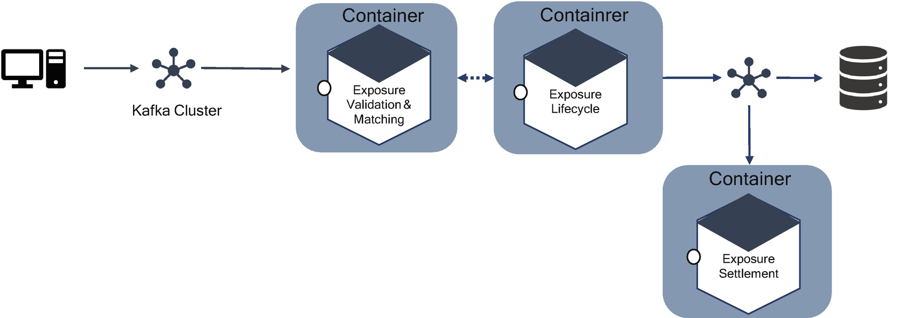

***Figure 5-8***

Distributed state with Kafka streams

In this example, an external system produces a message to the source topic in Kafka. Exposure microservices process the exposure messages using Kafka streams and writes calculated exposures to sink a topic in Kafka, and the consumer consumes new exposure messages. In this way, you can handle a seamlessly distributed state across microservices.

The second approach, as shown in Figure [5-9](https://learning.oreilly.com/library/view/cloud-native-architecture/9781484272268/html/511610_1_En_5_Chapter.xhtml#Fig9), is to use a distributed key-value pair caching technique such as Redis, Hezalcast, GemFire, etc., to handle distributed state across microservices.

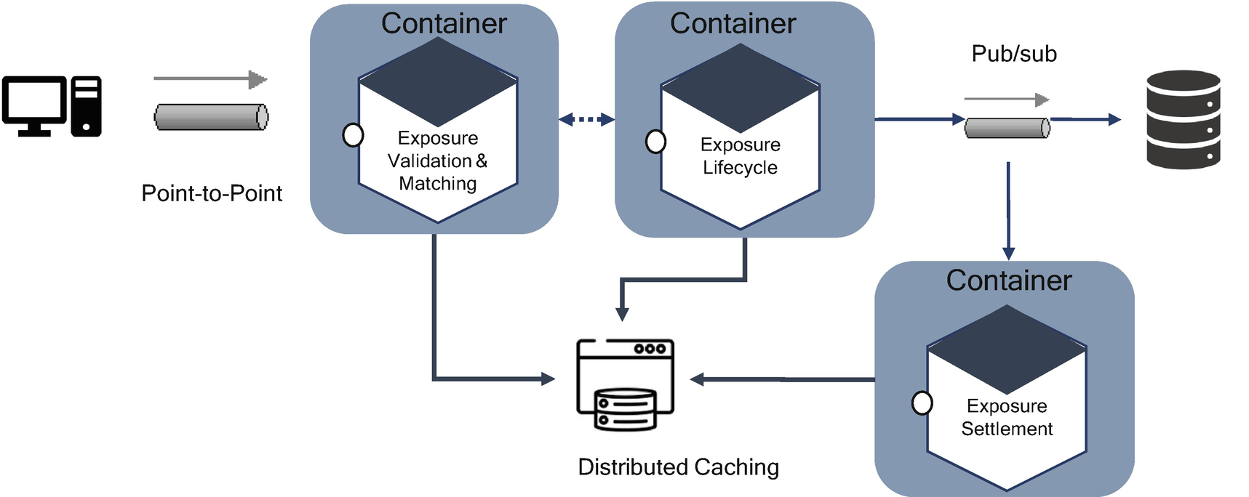

***Figure 5-9***

Distributed state with caching

In this example, the system sends a message in MQ, and exposure services consume and process and again publish the messages to exposure settlement and databases. The caching software stores session across microservices. The drawback of this approach is latency and single point of failure of caching software.

**Independently Deployable**

Microservices are a small unit of work, with the principles of the model related to the domain, bounded context, and polylithic and polyglot principles. Each microservice serves a single business responsibility and is loosely coupled with high cohesion and low coupling, which communicates across by using the HTTP, GRPC, and event messaging protocol only.

Microservices are owned by separate pod teams with their branching strategy and have less dependency on other microservices. These services to be deployed independently in a container and Kubernetes cluster. This type of deployment allows enterprises to test, modify, and add new business functionality independently without affecting other services in an application and allows them to scale up and scale down based on the load on a server, which helps to optimize the infrastructure cost.

**Decentralization**

You need to follow the decentralization principle for effective microservices. The main problem of centralization is to enforce central ideas, centralized technologies, etc., across the organization. My experience shows this approach is narrowing the thinking of team and innovation. Not every problem is a nail, and not every solution is a hammer. We need the right talent and the right software for the job.

Decentralization in microservices means the decentralization of governance, data, culture, team, and technology.

**Decentralized Governance**

Governance is a process to establish policies, standards, best practices, and guidelines to enable enterprise agility in an enterprise. In a traditional development methodology, we used to have a centralized governance team or centralized architecture board, etc., to make an entire decision on behalf of every unit in an organization irrespective of the team. This limited the speed, scale, innovation, automation, etc., and increased the cost of IT applications. Essentially, it did not support modern-day business.

In a cloud native, modern-day architecture, you need to encourage innovation and a culture of automation, scale, and speed. This can be possible only when you allow your team to work independently. The drawbacks of the decentralization approach are lack of control and duplication of development efforts, especially in midsize and large enterprises.

To succeed in the decentralization approach, you need to define effective collaboration, transparency, and well-defined standards, structures, and policies. Most important, your organization should embrace a culture of agility and automation. At Netflix, each team collaborates by sharing useful and tested code as libraries to encourage other teams to use them to solve similar problems and be open to picking up different approaches or modifying existing approaches. Similar to the Netflix model, you need to embrace a good model in your organization or develop a hybrid of your own.

**Decentralized Data**

In cloud native architecture, one of the microservice philosophies is the decentralization of data. A traditional monolithic approach uses a monolith database to store an entire application’s transactional data in one RDBMS. In a microservice architecture, the best approach is to adopt a polyglot persistence architecture as defined by Martin Fowler’s original microservices paper in 2014.

Correctly organizing data in the decentralization approach should be based on bounded context and API design. You are designing an API by providing a contract between your microservice and consumer, so in the database almost all the fields are related to your API contract, including operational fields and event storming events and related fields in the microservices. The design approach is to collect all API contract fields and events and group them in a related table and go through multiple iterations before finalizing the model.

The following are the main goals of a polyglot architecture:

* Remove scaling limits due to data access
* Avoid SQL joins
* Easier modeling of multipathing for performance
* Not restricted to one type of database; can use specific databases for microservices such as NoSQL or SQL
* Less potential for data model changes to have an application-wide microservices impact
* Simplified detection and correction of errors in production

One of the side effects of the decentralized approach is the ability to handle eventual consistency, synchronization of data, and latency.

**Automation**

Releasing microservices and new features to production rapidly and reliably with a single click is important for successfully managing microservice applications. You can achieve automation for the reliable deployment of microservices to production by using the principles of continuous integration (CI) and continuous delivery (CD). The fundamental building block of CI and CD is configuring a delivery pipeline with various tools, starting from the developer box to the production box.

In the delivery pipeline, an orchestrator like Jenkins configures various tools to run respective jobs starting from code check-in, code review, testing, security, performance, infrastructure as a code, and continuous monitoring. There are various good open source tools and cloud native PaaS services available to automate the entire pipeline.

Microservices are modular and intended to perform a single function. Modular software fits very well within the DevSecOps culture; thus, incremental code changes are easily pushed to production. Containerized microservices enable a quicker deployment, and services are immediately operational in production. Security in the pipeline for static code analysis (SAST) and dynamic code analysis (DAST) and container security both check for vulnerability at the early stage of the software. Automated operations and monitoring enhance the microservice approach to create an adaptable and scalable environment where deployment performs rapidly. Infrastructure as code automates the entire infrastructure, and containerization makes life easy for the entire development and infrastructure team, which reduces the cost and increases the quality of microservices.

By combining DevOps and microservices into development, testing will increase the efficiency of teams and reduce the cost. You can learn more about DevSecOps and get other automation details in Chapter [14](https://learning.oreilly.com/library/view/cloud-native-architecture/9781484272268/html/511610_1_En_14_Chapter.xhtml).

**Containerization**

A container is a standard unit of software that packages up code and all its dependencies so the application runs quickly and reliably from one computing environment to another. It is a lightweight, stand-alone, executable package of software that includes everything needed to run microservices. Containers are built once and can be run on any infrastructure, meaning on-premises or with any cloud provider.

A container enables the fine-grained execution of microservices and provides isolation and a lightweight size. Virtualization is big and takes a long time to boot and run. Microservices are elastic and tend to experience highly unreliable workloads, and virtualization takes more time than a container takes to react to a spike. During this time, you may lose lots of transactions.

Containers enable continuous integration by streamlining the creation of new application environments and continuous delivery by allowing containers to run unmodified across environments.

The following are the benefits of a container:

* The developer concentrates on developing an application and leaves the rest to automation and the container.
* Containers can run on any infrastructure, such as private, hybrid, or public cloud.
* Containers increase resource usage and control infrastructure spend.
* Containers enable standardization practices and patterns.
* Containers offer a faster time to market for new services.
* Containers reduce deployment failures.

A microservices architecture does not dictate the use of containers, but using containers for a microservices architecture is better for implementing your applications. Container environments accommodate colocated application components in the same operating system instance and will help to achieve better service utilization rates. You can find more about container architecture in Chapter [16](https://learning.oreilly.com/library/view/cloud-native-architecture/9781484272268/html/511610_1_En_16_Chapter.xhtml).

**Design for Failure**

Whatever system you use and however you design a system, you cannot avoid failure. Systems are bound to fail due to various reasons like network failure, server failure, catastrophic failure, natural disaster, a sudden spike in load, etc. An application needs to be designed so that it can tolerate the failure of services. If microservices fail, then you need to respond gracefully to the consumer.

Since microservices fail at any point in time, you need to design microservices to be able to detect the failure quickly and self-heal the failure. Microservices put a lot of emphasis on integrated real-time monitoring of application, infrastructure, and security and semantic monitoring. They need an early warning system so that you can use predictive analysis to heal the microservices

**How Do You Design a Microservice for Failure and Stability ?**

The first design consideration is to use the circuit breaker pattern to avoid the effect. As I mentioned in Chapter [4](https://learning.oreilly.com/library/view/cloud-native-architecture/9781484272268/html/511610_1_En_4_Chapter.xhtml), the circuit breaker pattern is commonly used to ensure that when there is a design failure, the microservice does not adversely affect other microservices in a system. This pattern works similarly to the electrical system of your home. It protects you from any adverse failure or power outage of your complex. Calls to microservices are wrapped in a circuit breaker object. When your microservice fails, the circuit breaker pattern allows subsequent calls to the service until a particular threshold of failed attempts is reached. At this point, the circuit breaker trips, and any further calls will be short-circuited and will not result in calls to the failed service.

The second design consideration is to use the bulkhead design pattern to avoid the effect. As we mentioned in Chapter [4](https://learning.oreilly.com/library/view/cloud-native-architecture/9781484272268/html/511610_1_En_4_Chapter.xhtml), the bulkhead pattern is like a ship’s hull that is composed of individual watertight areas. The reason for this is if one bulkhead fails, it does not impact the whole ship. You need to apply this kind of partition in your microservices design. Assume that your consumer sends requests to multiple services simultaneously. During this time your service is unable to respond in a timely manner due to various reasons; at that point requests from the consumer to other services are also affected. Eventually, the consumer can no longer send requests to other services. In a microservices world, you cannot completely avoid a dependency across microservices to provide final responses to the consumers; therefore, you need to maintain intercommunication between microservices. You need to make sure you follow independently deployable principles to avoid cascading failure.

The third design approach is integrated real-time monitoring to monitor the real-time health of your microservices. You need to configure all your services with event-driven architecture to send monitoring and traces of your services in real time to monitoring tools. This helps you with early detection to avoid failure. More details of integrated monitoring can be found in Chapter [19](https://learning.oreilly.com/library/view/cloud-native-architecture/9781484272268/html/511610_1_En_19_Chapter.xhtml).

The fourth design approach is to apply machine learning predictive analysis to the health of the system. There are widely different failure prediction techniques available. The prediction algorithm can be created and trained based on the event log of a microservices, time-series data like CPU, etc. For errors captured in the event log, you can use pattern-recognition tools that run over log files to detect faulty behavior based on certain rules. Rule-based predictors derive failure in log files by gathering rules that indicate failure. The symptom monitoring method will detect symptoms of failure in the microservices based on several metrics collected in integrated monitoring. System model predictors use the CPU utilization and memory usage metrics to calculate the failure of a system. Once you gather the prediction, then you send signals to the container by using the container’s lifecycle conformance principle and infrastructure as code to spin up a new container image of microservices and gracefully shut down the old.

The fifth design approach is to use failure as a service (FaaS). Failures are severe for any services, and customers cannot wait for you to fix the problem. The top ten digital trends in digital transformation believe the failure service influences how the software will be developed and tested. Use failure testing in your system; it is an approach that allows your team to discover weak spots that can lead to failure. The probability of failure parameter plays a major role in understanding the health of an application. Cloud service outages still take place. According to Netflix, there are many unknown real production scenarios in which a failure recovery might not work. Amazon has leveraged “game-day” exercises that inject real failures like EC2 failures, power outages, etc. There are many ways to test failures and failure as a service, such as the shift-left approach and chaos monkey. How failure services are tested will be explained in Chapter [12](https://learning.oreilly.com/library/view/cloud-native-architecture/9781484272268/html/511610_1_En_12_Chapter.xhtml).

**Living Continuous Design**

In traditional development, the architecture and design could be planned at the start of the project or product. Once the team defined the architecture and design, the development should follow it, and there was very little room to change the defined plan. Now we have a rapidly changing environment to support unbelievable disruption in business and rapid changes in customer expectations. The team might not have any idea what next change comes and how your end customer interacts with your application. In a similar way, the technology is changing rapidly, and a lot of greater innovation is happening. Whatever the technology you use today to do development may become obsolete in the next two years.

You should always adopt a design mechanism that can manage change. The primary objective of a living continuous design is to enable your architects and engineers to have continual and incremental change support embedded in the application. The living design also ensures that your system is not fragile.

The living continuous design supports nonbreaking changes to ensure that we can adopt continuous design and derive various services. One of the evolutions of a living continuous design is the microservices architecture style. Microservices demonstrate a living design need.

Two features of living continuous designs are modularity and coupling. A living continuous design supports modularity, and microservices are decoupled from each other. Whenever there is a change in one microservice, it will not impact any other service in the system.

To get the benefits of a living continuous design, you must test the architecture and design. This test is done by adopting a fitness evaluation and identifying challenges and risks at the early stage. There are various fitness functions and methodologies that can be used to identify the fit of the architecture. How and what methodology and functions are used for fitness tests will be explained in Chapter [12](https://learning.oreilly.com/library/view/cloud-native-architecture/9781484272268/html/511610_1_En_12_Chapter.xhtml).

**Self-Healing**

In an enterprise, there are several microservices that evolve daily. The management of these microservices becomes complex, which leads to a chance of failure that is very high even though you designed your microservices with the principles of failure and resilience. Therefore, you need to design your microservices to be self-healing at runtime. In normal circumstances, you can configure the services to send an alert if a service misbehaves so you can examine these alerts and fix the anomalies. You need to bring down the service, fix it, and deploy it, and this is a manual operation. What if your organization has more microservices across various systems? Is it possible to do that manually? If yes, how much effort and resources are required? Self-healing of services is one of the options to automate the failure process.

A self-healing microservices architecture, as shown in Figure [5-10](https://learning.oreilly.com/library/view/cloud-native-architecture/9781484272268/html/511610_1_En_5_Chapter.xhtml#Fig10), has the ability to continuously monitor the integrated operational environment, including the application, infrastructure, and security; detect and observe anomalous behavior; and provide a self-healing and self-tuning mechanism to adapt to sudden changes in its operational environment dynamically at runtime.

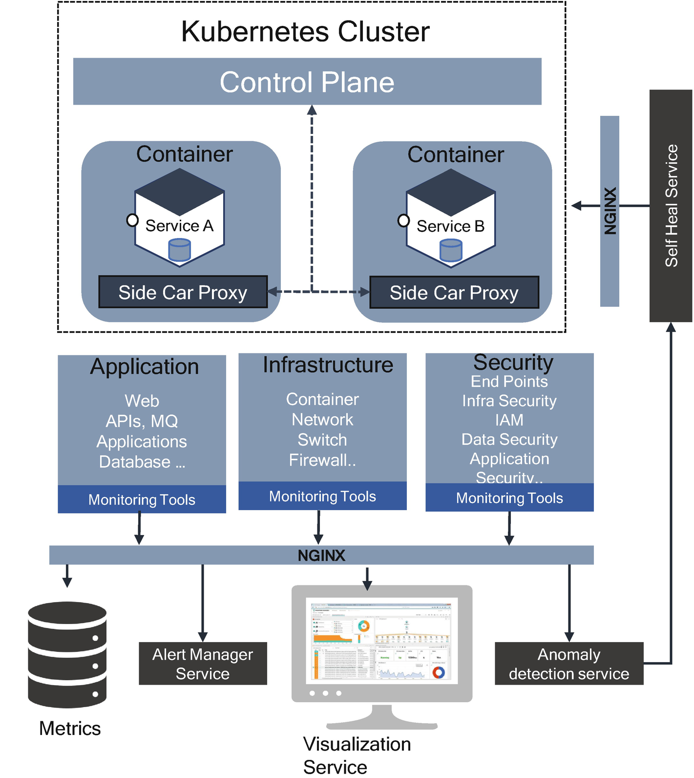

***Figure 5-10***

Self-healing ability in microservices

Metrics are collected continuously from the application, infrastructure, and security. The metrics are for cluster nodes, services, and containers and include CPU usage, memory, disk reads and writes, and network reads and writes. These metrics are streamed in real time into the metrics database. After you capture the service metrics, you need to run simple anomaly detection services continuously on the collected metrics and enable the training of a model with the collected metrics with simple rules.

The anomaly detection service provides the continuous detection of anomalous behavior and prediction about the microservice’s performance based on the metrics collection. The identification of continuous detection is based on the parameters of CPU usage, memory, disk, and network reads and writes against the normal behavior parameters of the microservice and health scores of different services. The scores are weighted by using a linear equation or a time decay function. Based on the score, a microservice is bucketed into three zones such as red, yellow, and green.

The scores are calculated based on the metrics you collected. Here are some examples:

* CPU utilization = 1
* Memory utilization = 1
* Error logging = 1
* Response time = 1
* Disk reads and writes = 1
* Network reads and writes = 1

Use the following formula to calculate the score of metrics:

* **Score of each metrics** = (current value – normal behavioral value)/(critical value -normal behavioral value)

For CPU utilization, assume normal behavioral value is 0.5 and a critical value is 1.5.

* **Score of CPU Utilization** = (1-0.5)/(1.5-0.5) = 0.5/1= 0.5.

Here you can say your microservices are running normally.

**Note**

The critical and normal behavioral values will be different for every metric and every application.

The microservices score will be calculated as the summation of all the metrics scores:

* **Microservice score** = Σpi*wi / Σwi

If the microservice score is less than the critical score, then there is no need to take any action; if the score is above the critical level, take an action.

All this automated calculation is part of the anomaly detection service that calculates automatically in real time and sends a notification to the self-healing service to execute the action.

The self-healing service executes the outcome of the anomaly detection service algorithm by injecting the container principles detailed in Chapter [3](https://learning.oreilly.com/library/view/cloud-native-architecture/9781484272268/html/511610_1_En_3_Chapter.xhtml). If the algorithm score is bad, it deletes its entry from the NGINX upstream list and kills the container by using the lifecycle conformance principle’s SIGTERM and SIGKILL commands of the container. If the score is average, then reduce the load on NGINX for the respective microservices; if the score is good, then do not take any action.

**Hexagonal Architecture**

The hexagonal architecture , or ports and adapters architecture, is an architectural pattern used in software design. It creates loosely coupled application components that can be easily connected to their software environments using ports and adapters. This makes components exchangeable at any level and facilitates test automation.

The main idea of a hexagonal architecture is to provide interaction to the outside world at the edges of your design. The domain logic should not depend on what you expose as a REST or MQ, and your microservices should not depend on where you get data, whether through a database or NoSQL etc.

In a traditional layered architecture, you have a user interface, business logic or backend application layer, and database layer. All these layers are tightly coupled to each other. If you want to replace a database with another, then you need to change the data access layer within the application logic to accommodate the changes such as connections, SQL queries, etc. The hexagonal architecture addresses these concerns of tight coupling across various layers.

The concept of hexagonal architecture, as shown in Figure [5-11](https://learning.oreilly.com/library/view/cloud-native-architecture/9781484272268/html/511610_1_En_5_Chapter.xhtml#Fig11), is to create domain microservices without a UI or a database and run a test suite on domain services and later link the UI and services by using the adapters. It divides microservices into several loosely coupled and replaceable components, such as domain logic, adapters, platforms and infrastructure, test services, external systems, platform services, etc. Each component is connected with the other through a port and through communication with other applications or UIs or platforms through this ports.

This architecture allows you to isolate the core domain logic of microservices from the outside. This will help to change the data source details and API protocol details without a significant impact on code domain logic. The main advantage is to provide a clear boundary for testing. If data source changes, test only that part, entire your not microservice.

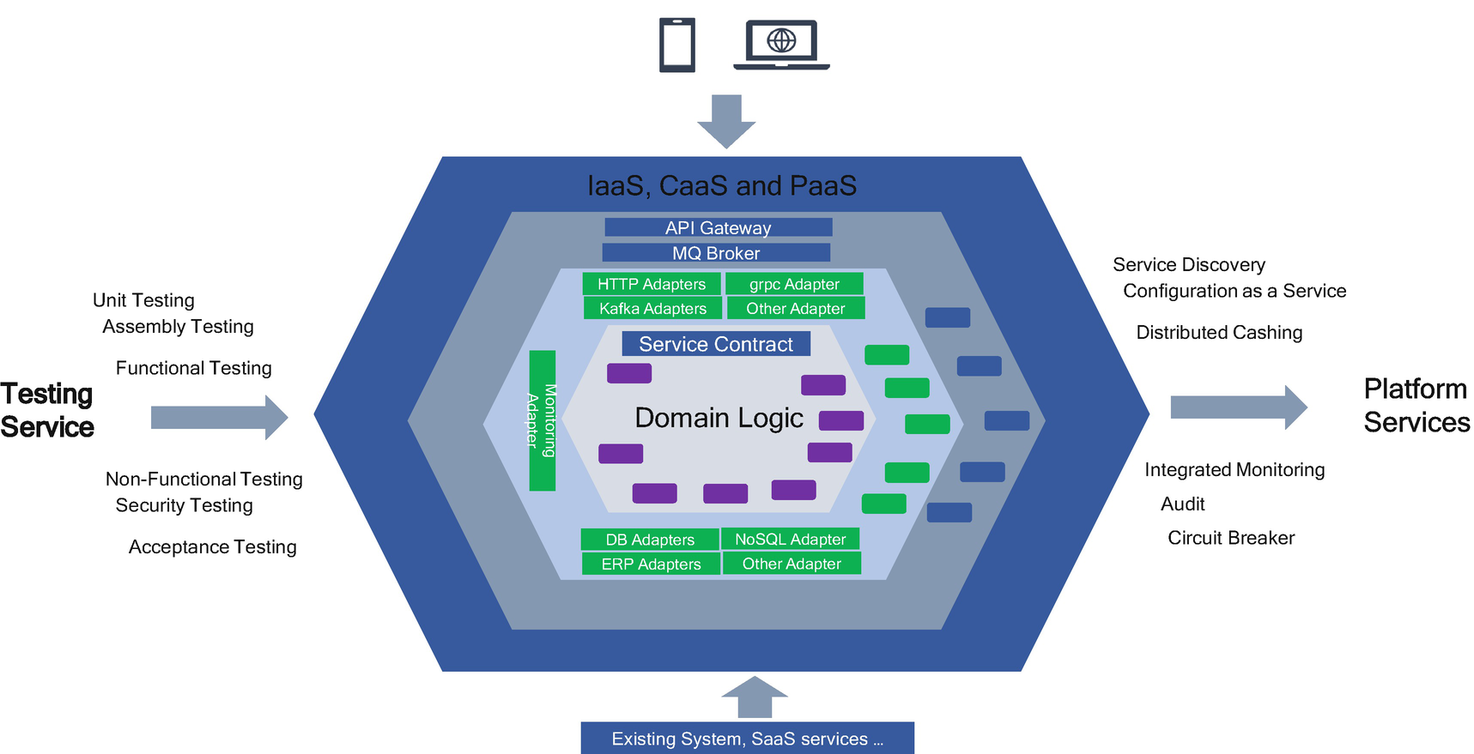

***Figure 5-11***

Hexagonal architecture

In Figure [5-11](https://learning.oreilly.com/library/view/cloud-native-architecture/9781484272268/html/511610_1_En_5_Chapter.xhtml#Fig11), the four layers to define business logic are as follows:

* Infrastructure layer where your microservices are deployed
* Platform layer where your API gateway, Kafka cluster, MQ broker, etc. are
* Adapter layer where your adapters are placed, which connects with external systems and your core domain logic of microservices
* Domain logic layer, where you construct the domain business functionality

With these four layers, you can define the business logic without any knowledge of where the data is kept and how the business logic is triggered and how consumers interact.

There are DB adapters for different storage implementations such as the RDBMS database or NoSQL adapter for document or key-value databases. A data source implementation method is defined in the adapters and stores the implementation of fetching and creating the data.

The communication adapters are input for your microservices. The communication adapters such as HTTP, GRPC, MQ, or Kafka, etc., include transport information from the consumers or requestors. All the interaction logic is constructed in the communication adapters and separated from the core domain business logic.

For some reason, you want to swap the database from existing RDBMSs like MySQL to a NoSQL like MongoDB and then without any trouble replace the MySQL adapter with the MongoDB adapter in very little time.

A new consumer wants to get some details from your microservices, but they listen only with MQ messages; you can bind the MQ adapter with your microservices and provide a queue name to the consumer. Therefore, the consumer can configure their system with a new queue name. That’s it; they start receiving the details from microservices.

The hexagonal architecture simplifies the testing services. For seniors such as DB replacement and new consumers with an MQ adapter, the scope of the testing is only to test the adapters, not the core business logic, because you have not touched the code. In this case, just run the few regression test cases to complete the testing cycles.

Let’s figure out how the normal microservices architecture, as shown in Figure [5-12](https://learning.oreilly.com/library/view/cloud-native-architecture/9781484272268/html/511610_1_En_5_Chapter.xhtml#Fig12), differs from a hexagonal microservices architecture.

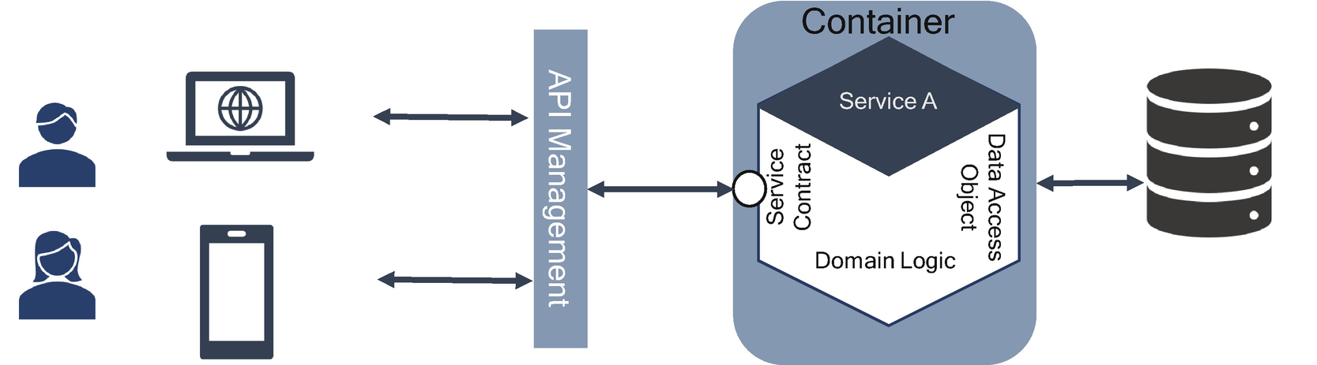

***Figure 5-12***

Normal microservices architecture

In the normal way, as shown in Figure [5-12](https://learning.oreilly.com/library/view/cloud-native-architecture/9781484272268/html/511610_1_En_5_Chapter.xhtml#Fig12), usually in the microservices architecture, you have domain logic created using any programming languages such as Spring Boot, Golang, .NET, Scala, etc., and it exposes the REST API contract between consumers and domain logic. Here the consumers can be a mobile application or web application or third-party application. The domain logic interacts with the repository to store or retrieve information from databases like NoSQL or RDBMS, etc., based on the consumer request by using HTTP methods like PUT, POST, GET, TRACE, etc. Here all service contract controllers and data logic are coupled in a single microservice with multiple subcomponents in it.

If you want to replace or modify the database, then you need to change the entire microservice and carry out entire regression testing of your microservices and for the new consumer with queues.

The following are the drawbacks of hexagonal architectures:

* Increases in the latency
* Additional complexities to manage adapters

**Enterprise Microservices Examples**

In previous chapters, you learned about certain patterns, and so far in this chapter, I have explained microservices, characteristics of microservices, etc. These topics cover how to solve various microservices problems. In the next few sections, I will cover how to wire all this together to explain the real-time microservices implementations. These are the examples from various industries, and I have been personally involved in architecture, design, and implementation of the real-life examples.

**Case Study: Trade Finance**

A trade finance project was implemented for Bank A. Bank A was doing millions of transactions with a value in the billions. They want a seamless and cloud native architecture for their new trade finance module. We proposed microservices and event-driven architecture and deployed them on the Azure cloud platform.

The following sections provide the details of the functional components and architecture components.

**What Is Trade Finance?**

Trade finance is the financing of international trade flows. It exists to mitigate or reduce the risk involved in an international trade transaction. In trade finance, an exporter requires payment for their goods and services, and an importer wants to make sure they are paying for good quality and for a specific quantity.

**Trade Finance Ecosystem**

As shown in Figure [5-13](https://learning.oreilly.com/library/view/cloud-native-architecture/9781484272268/html/511610_1_En_5_Chapter.xhtml#Fig13), the seller or exporter can require the purchaser or importer to prepay for the goods shipped, and the purchaser may want to reduce the risk by requiring the seller to document the goods that have been shipped. Banks may assist by providing various forms of support. The importer’s bank may provide a letter of credit to the exporter, and the exporter’s bank may provide a payment upon presentation of certain documents, such as a bill of lading. The exporter’s bank may make a loan by advancing funds to the exporter based on the export contract.

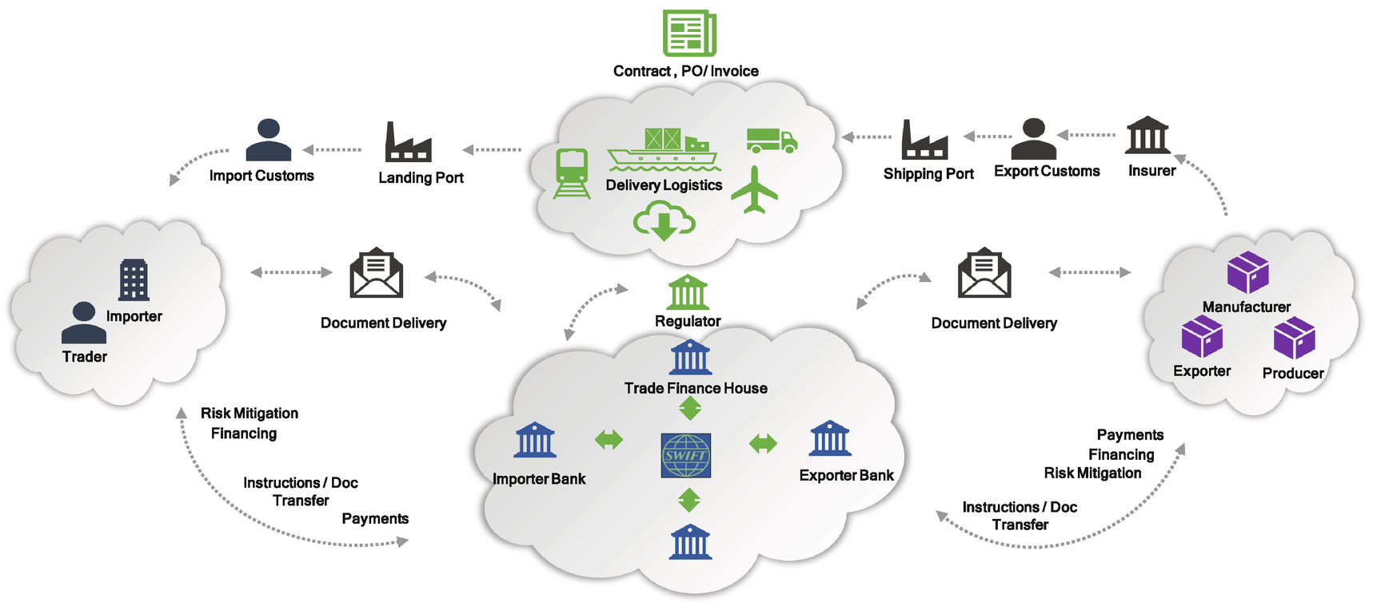

***Figure 5-13***

Trade finance ecosystem

**Trade Finance Functional Architecture**

As shown in Figure [5-14](https://learning.oreilly.com/library/view/cloud-native-architecture/9781484272268/html/511610_1_En_5_Chapter.xhtml#Fig14), the following are the functional components required to build a trade finance application for any commercial bank; these functional components are not limited to the ones shown in the diagram:

* *Letter of* **c***redit (L/C)*: As shown in Figure [5-15](https://learning.oreilly.com/library/view/cloud-native-architecture/9781484272268/html/511610_1_En_5_Chapter.xhtml#Fig15), in a documentary credit, a buyer asks a commercial bank to issue an L/C in favor of a seller. The issuing bank must pay the seller once it receives and verifies the proper documents for the trade.
* *Collections*: Banks act as intermediaries and present the sellers’ shipping documents to the buyer as proof of transfer.

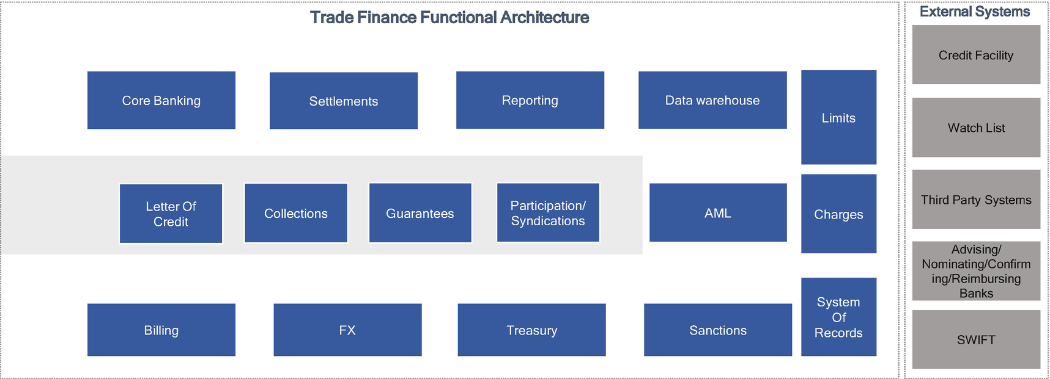

***Figure 5-14***

Trade finance functional architecture

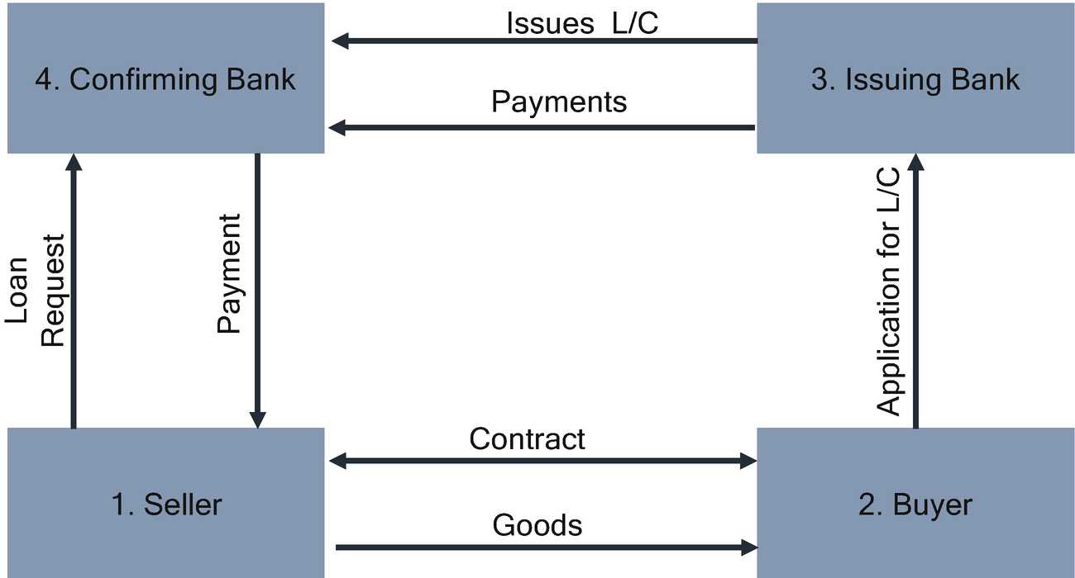

***Figure 5-15***

Letter of credit flow

* *Settlements*: This is the transaction wherein the securities being trade are transferred into the buyer’s account, and the monetary value of the security is deposited into the seller’s account after the trade execution.
* *Guarantees*: This is a way for buyers and sellers to prove their credit worthiness. It promotes confidence in a transaction that will greatly encourage the process. It is a promise to make a payment to a seller in certain circumstances, such as failure of obligation from the buyer.

The Figure [5-16](https://learning.oreilly.com/library/view/cloud-native-architecture/9781484272268/html/511610_1_En_5_Chapter.xhtml#Fig16) architecture is implemented for the previous functional architecture. The architecture is based on the API first principle by using Open API standards, DevSecOps for automation, cloud enablement with Azure Cloud, product principles, and frictionless upgrade design principles.

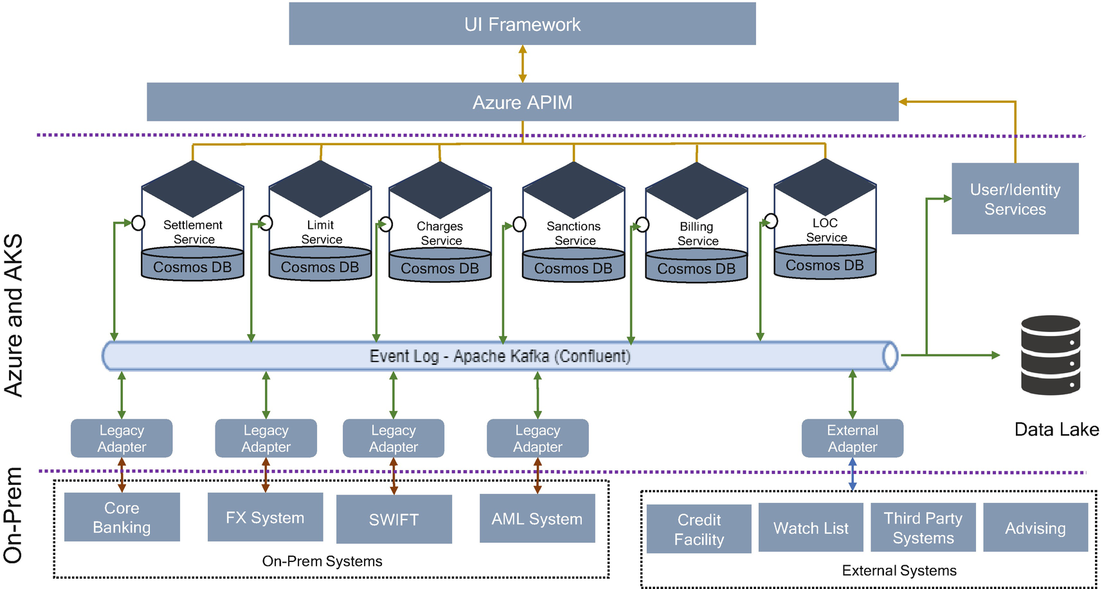

***Figure 5-16***

Trade finance microservice architecture

From an architecture point of view, microservices split a functional component into a service that is independently replaceable and upgradeable and is organized around a business capability, as mentioned in the diagram.

The architecture is implemented with microservices and event-driven architecture and with polyglot principles. Microservices such as settlement services, limit services, charge services, sanction services, billing services, and L/C services are deployed in the container by using Azure Kubernetes services, and each service interacts via an Apache Kafka implementation.

These architecture-provided APIs are the interaction mechanism with the external applications and UI dashboard. The architecture is provisioned in Kubernetes on Azure and with managed security on Spring Boot services using Helmet, Passport, and NGINX reverse proxies.

All trade finance services need to connect to various other existing bank applications such as core banking, Forex, SWIFT, etc., that reside in the on-prem data center and connect through legacy adapters by using a VPN connection. Anti-Money Laundering (AML) is an batch activity and audits every transaction in the trade finance industry and also connects to third-party systems like watch list, credit facility, etc., through the external adapter.

All events and transactions are sent to the data lake (Azure Blob) for further analytics and reporting.

**Case Study: Collateral Management**

As shown in Figure [5-17](https://learning.oreilly.com/library/view/cloud-native-architecture/9781484272268/html/511610_1_En_5_Chapter.xhtml#Fig17), the collateral management service aims to manage the collateralization of exposures resulting from bilateral trading activities between counterparties (repos, securities lending transactions, OTC derivatives, and so on) including activities subject to clearing.

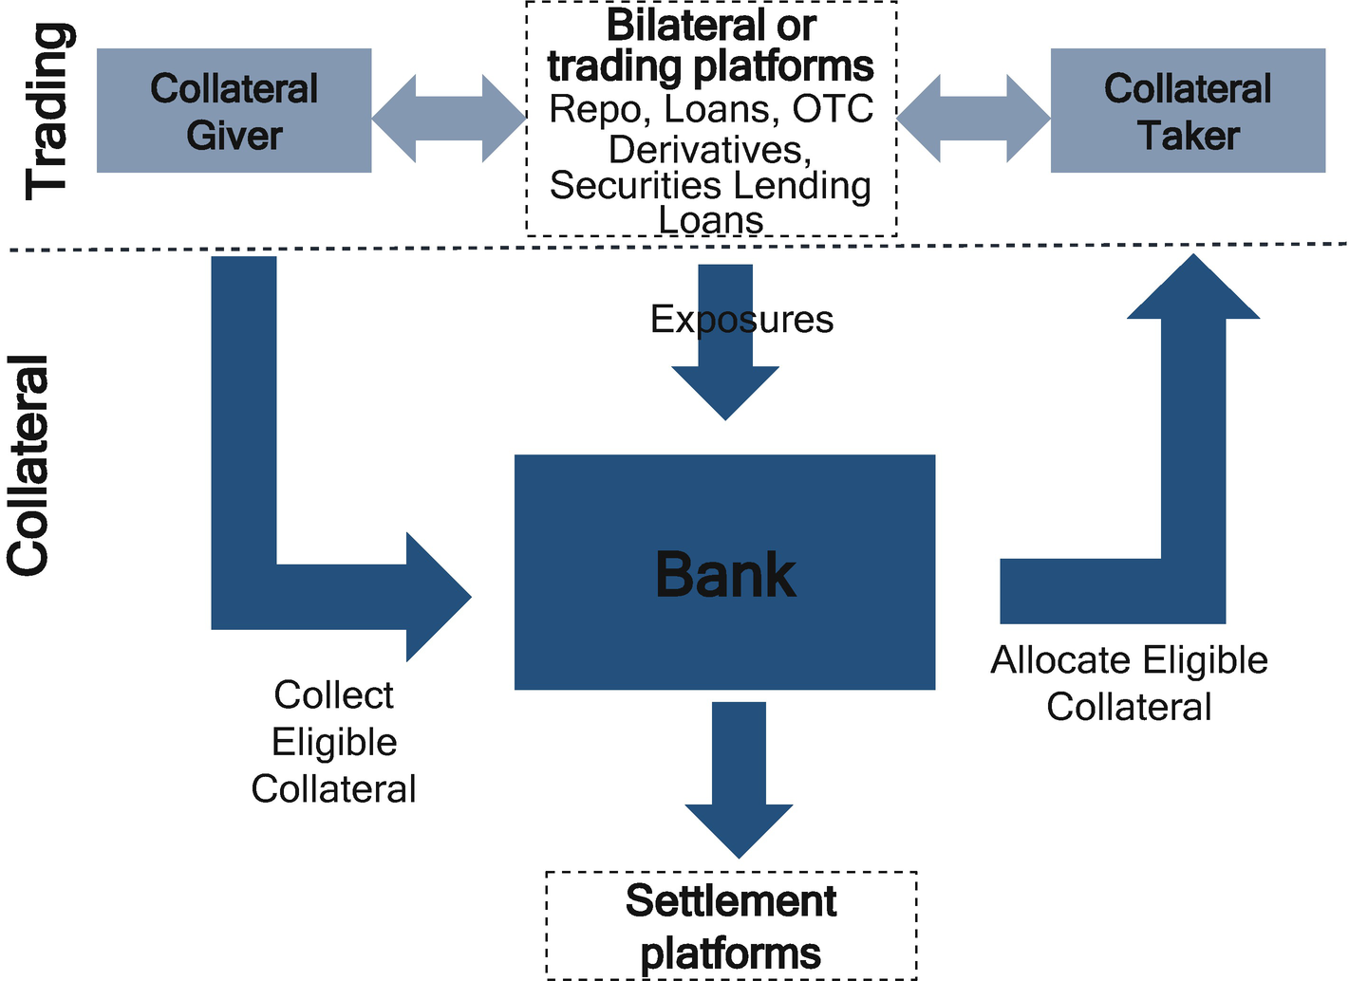

***Figure 5-17***

High-level collateral interaction

Processing between the collateral giver and taker (collateral selection, payment and settlement, and management during the life of transaction) is managed by the agents. These agents are the collateral portfolio managers of a bank.

**Collateral Management Functional Architecture**

As shown in Figure [5-18](https://learning.oreilly.com/library/view/cloud-native-architecture/9781484272268/html/511610_1_En_5_Chapter.xhtml#Fig18), the collateral management consists of several items.

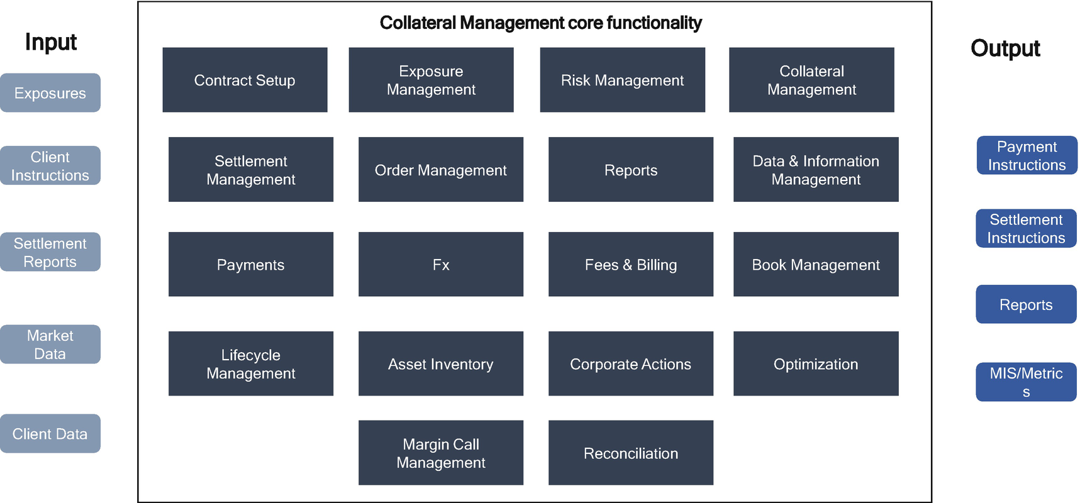

***Figure 5-18***

Collateral management functional architecture

* *Contract* *setup*: This module sets up and maintains legal terms contained within the collateral management application for collateral agreements signed between the collateral giver and collateral taker. This module stores other eligibility metrics and haircuts, account structure, and client preferences.
* *Exposure* *management*: This is an entry point of exposure into this application. This module performs validation, matches exposures, and manages the lifecycle of an exposures.
* *Risk* *management*: This module performs the amounts to be covered for the collateral book and evaluates the value of the collateral assets allocated, considering haircuts and eligible criteria. This module calculates the uncovered amounts and triggers margin calls to the collateral application.
* *Collateral* *management*: This module assesses the available inventory of collateralizable assets and runs an algorithm to determine the optimal collateral allocation based on given constraints, priorities, and preferences.
* *Settlement* *management*: This module captures the required collateral movements and instructs the necessary settlement systems for execution and manages the settlement failures.
* *Order* *management*: This module receives collateral status notification and updates the collateral books accordingly.
* *Reports*: This module generates all the required data for all different consumers including data required for optimization algorithms.

The rest of the modules are standard such as collateral fees, billing, payments, Fx rates, book management, etc.

**Collateral Management Architecture**

Collateral management is a highly transactional and real-time processing of data. We decided to design collateral application with microservices and event-driven architecture principles because:

* Each component in collateral modules handles different types of transactions and needs to be scaled independently. For example, risk management requires highly scalable and robust services because it calculates and manages the collateral books in near real time based on the equity, Fx rates, etc. The contract module does not require much scalability because contracts are signed at the beginning of the collateral agreement.
* We adopted an event-driven architecture for publish-subscribe and real-time communication across microservices.

The technologies used for this application were Spring Boot, Active MQ, APIs, JRules, Data Grid Distributed Cache, and Postgres SQL.

As shown in Figure [5-19](https://learning.oreilly.com/library/view/cloud-native-architecture/9781484272268/html/511610_1_En_5_Chapter.xhtml#Fig19), all microservices are designed to deploy independently and scale independently. Each microservice was designed and developed with Spring Boot and deployed in the Red Hat Open Shift environment.

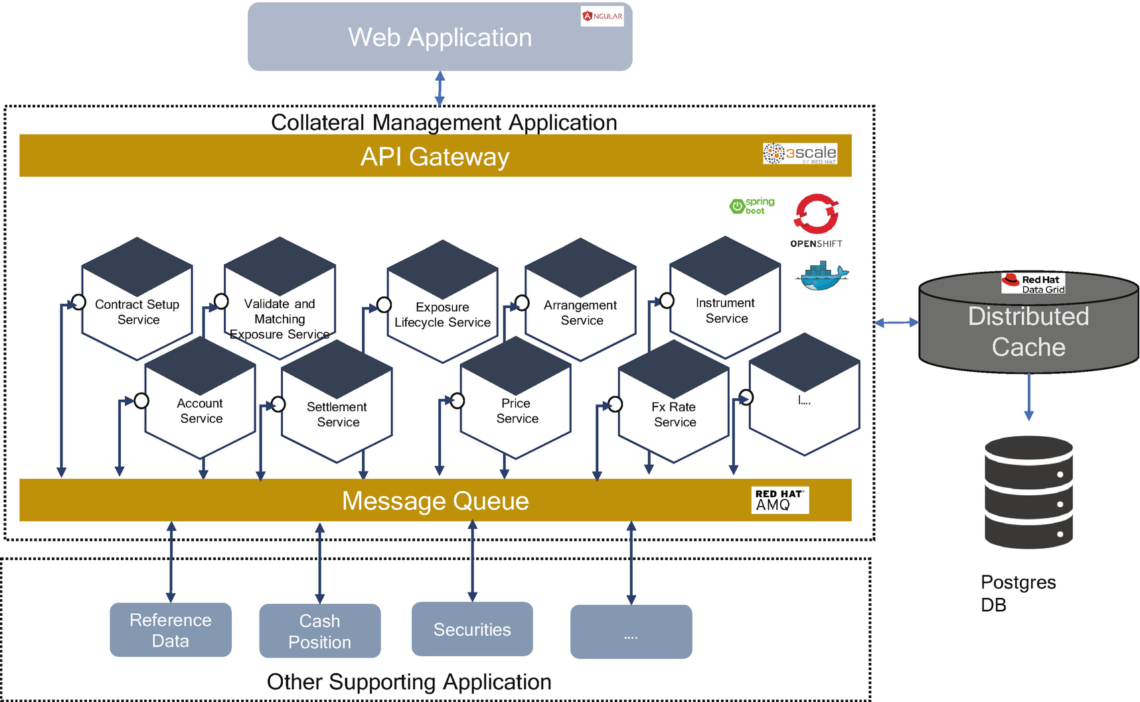

***Figure 5-19***

Collateral management architecture

All microservices are event sourced and stored in the distributed cache and eventually stored in a Postgres database. The state is stored in the Active Message Queue as events and then passed across microservices and stored in the databases. The microservices are deployed in the container in an Open Shift environment for the runtime platform and automatically deployed by using the Jenkins and Ansible Tower infrastructure as code solutions.

**Microservices and User Interface: Micro Front End**

There are two ways to implement the user interface of a microservice application:

* Front-end monolith, as shown in Figure [5-20](https://learning.oreilly.com/library/view/cloud-native-architecture/9781484272268/html/511610_1_En_5_Chapter.xhtml#Fig20)
* Micro front end, as shown in Figure [5-21](https://learning.oreilly.com/library/view/cloud-native-architecture/9781484272268/html/511610_1_En_5_Chapter.xhtml#Fig21)

A micro front-end architecture is a design approach in which a front-end app is decoupled into individual, semi-independent micro apps working loosely together. The micro front end is an extension of microservices.

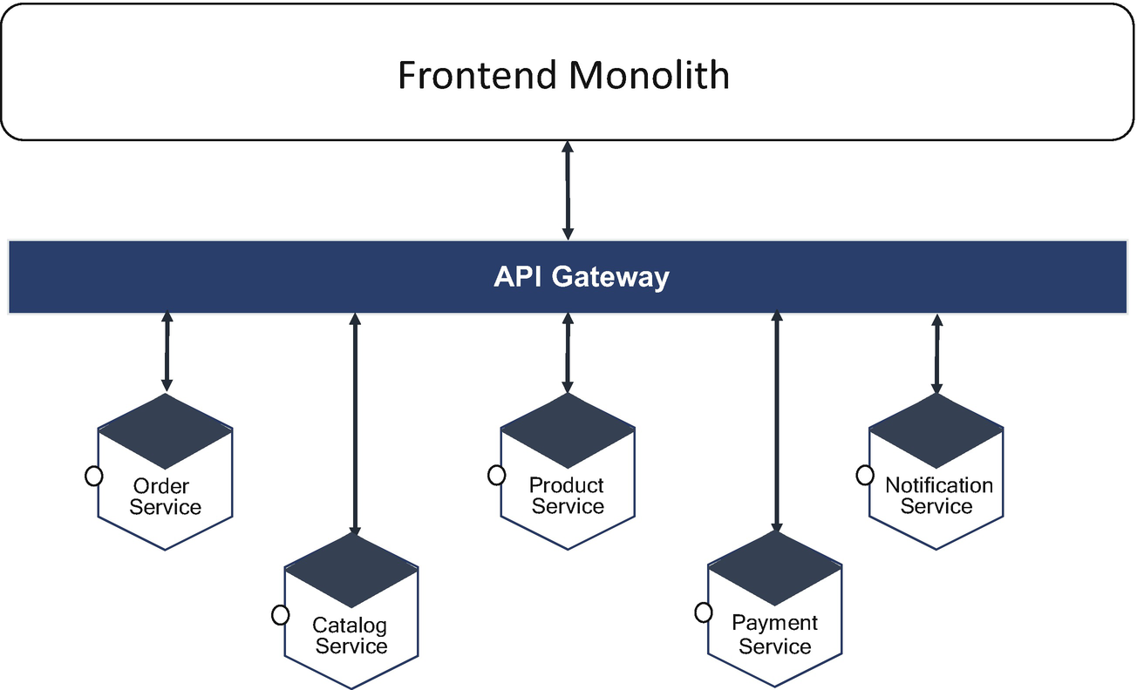

***Figure 5-20***

Front-end monolithic with microservices

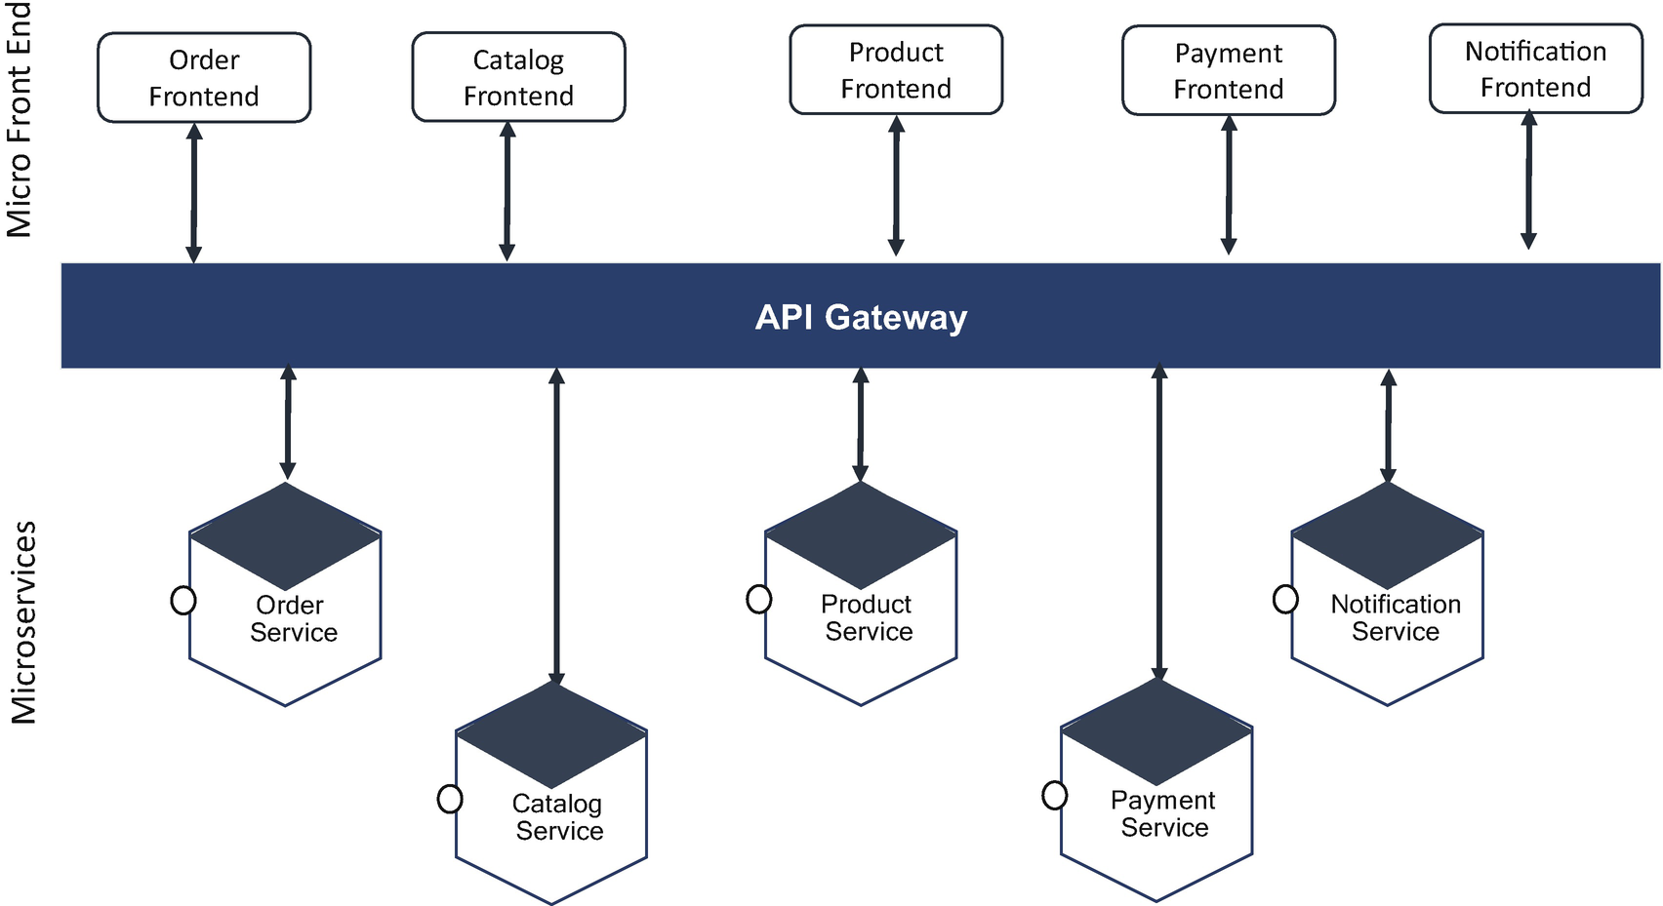

***Figure 5-21***

Micro front end with microservices

The micro front-end approach is different from other architectures in the way we think about and build features. Teams have an end-to-end responsibility for a given functionality and start building from the polyglot persistence, microservices, and micro front end.

The next question is, how do we integrate all the siloed pages and serve customers as a single unit? You can achieve this by using the front-end integration technique.

Front-end integration is a set of techniques you use to assemble the user interfaces of the teams into an integrated application. The techniques are as follows:

* Routing
* Composition
* Communication

**Routing**

The routing technique is about integration at the page level. You need a system to get from a page owned by the Order and Catalog pages. Here you can use an HTML link to integrate the Order and Catalog micro front ends. If you want to navigate from the Catalog page to the Order page, you don’t need to reload; use a shared application shell or meta-framework like single-spa.

**Composition**

In the composition technique, each fragment in pages is collated and put in the right slot on a page. A separate composition technique does the final assembly. You can do that assembly by using server-side composition and client-side composition with SSI, ESI, iFrames, Ajax, or web components.

**Communication**

For interaction across applications, you need communication across multiple micro front ends. In our example, the Order page gets an update after adding an Order button to a Catalog page, and payment is done after the order is completed. You can achieve this integration by using communication techniques.

**Pros and Cons of Micro Front Ends**

The advantages of micro front ends are as follows:

* The individual team can choose their technology and ownership.
  + Combined with microservices, fully autonomous end-to-end teams can be deployed.
  + The business has flexibility to create teams focused on specific domains.
* Development and deployment are very quick.
* The benefits of microservices are leveraged in a much better way.

These are the challenges of the micro front end:

* UX consistency is an important aspect.
* User experience may become a challenge if each individual team goes in their own direction; hence, there should be some common medium to ensure UX is not compromised.
* Dependency needs to be managed properly.
* Multiple teams working on one product should be aligned and have a common understanding.

**Microservice Architecture in Artificial Intelligence**

You already know that some of the applications you use in day-to-day life use artificial intelligence (AI) , such as Alexa, Google Home, Spotify, Siri, etc. These AIs are a set of programs developed to perform specific tasks.

AI will be a de facto standard and usage pattern for several objects in an industry, and it will grow spontaneously year after year. This will increase the number of objects or use cases and creates many challenges and opportunities for enterprises. In the broader vision of AI, every connected object in an industry will be reused in multiple AI application domains for enhancing the smartness and intelligence of the AI application.

The intelligence in AI is composed of the following five characteristics:

* Reasoning
* Learning
* Problem solving
* Perception
* Linguistic intelligence

When you define an AI application with this set of characteristics, the AI architecture must follow the pattern of separation of concern. If not, then it becomes a single, all-in-one, monolith kind of application. Then it follows the same approach for the provisioning of AI services. A better architecture for AI must be based on the microservice architecture style.

In the era of digital transformation, AI is emerging with improved data collection methods, data training sets, advanced data processing mechanisms, enhanced analytic techniques, and a modern service platform. If you separate the implementation into similar groupings, then it can be developed and maintained easily without much effort and risk.

The microservices style can be adopted in AI systems for marketing, banking, finance to predict future data, agriculture such as climate change, population growth, healthcare like medical care systems, clinical decision support systems, gaming, autonomous vehicles, and social media.

For all these kinds of AIs, microservices are the best approach for the activities such as data processing, data aggregation, and data transformation. They can be processed by using a pipeline with events.

**AI Subcategories**

The horizontally layered platforms do not address the issues of specific AI domains, but they support necessary technical solutions across the platform; however, the vertical components are used to resolve domain-specific problems. Figure [5-22](https://learning.oreilly.com/library/view/cloud-native-architecture/9781484272268/html/511610_1_En_5_Chapter.xhtml#Fig22) shows the vertical components.

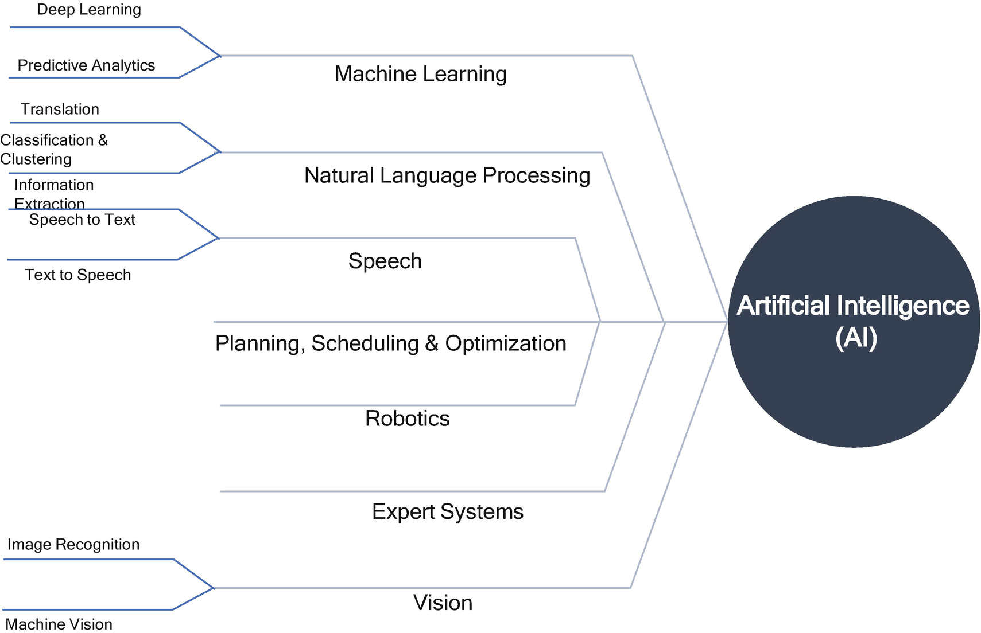

***Figure 5-22***

AI subcategories

Generally, the architecture of an AI component is modular and layered.

The first layer is to read the data and do data processing, data aggregation, data transformation, etc.

The second layer is to apply the execution layer like ML models and the execution layer for machine learning, foundation model and cognitive services for intelligent agents, automation engine and recognition engine for robotics, etc.

The third layer is for exposing the APIs like the Text/Speech API, Image API, Predictive API, Ecosystem API, etc.

The vertical components can be developed by using the microservice architecture style, which improves the service modularity, extensibility, availability, scalability, resilience, etc., for AI services.

**Microservices Vertical Components: Speech AI**

Let’s look at an example of a Speech AI implementation to explain the details of microservices adoption; you can follow a similar approach for other AI implementations.

Speech recognition is an area of natural language processing and artificial intelligence. When trying to achieve good accuracy and efficiency of automatic speech recognition systems of various languages, the challenges are morphology, language barriers, different dialects, etc.

Here are a few AI-based speech implementations:

* Google’s AI speech recognition to human captioning for television news
* AI that can understand the meaning of a baby’s different cries to tell if the baby is hungry, tired, or in pain by listening to their cries
* Transcription performance milestones on automatic broadcast news captioning
* Alexa for Business Review
* Google updates to Maps, Search, and Assistant so you can order food without an app
* Google AI to help you speak another language in your voice
* DIY kid smart speaker that features a private voice assistant
* Google AI Translation to make anyone a real-time polyglot

If you search Google, you can find hundreds of different AI-based speech applications and implementations. Do you think all these application architectures are reusable, resilient, easily deployable, and easy to discard? No? How do you create new AI-enabled microservices speech software?

A speech recognition program works using an algorithm through the following:

* Acoustic modeling
* Linguistic modeling

In Figure [5-23](https://learning.oreilly.com/library/view/cloud-native-architecture/9781484272268/html/511610_1_En_5_Chapter.xhtml#Fig23), each blue box has its responsibility and can be developed with polylith and polyglot principles, and each box can scale and deploy independently; hypothetically, each box is a candidate for microservices.

For example, let’s consider an example of any Indo-Aryan language that evolved from Devanagari script. Each language is spoken by more than a million people. Each language in India has a rich morphology and a complex structure of syntax. The diversity of dialects in the form of pronunciation, grammar, and vocabulary make speech recognition more complex. Converting speech into a text mechanism for Indian languages includes major limitations regarding accuracy because of the bulk corpora set, etc.

As shown in Figure [5-23](https://learning.oreilly.com/library/view/cloud-native-architecture/9781484272268/html/511610_1_En_5_Chapter.xhtml#Fig23), the basic architecture of speech processing, recognition, and modeling requires a well-thought-out and reusable design model to process many languages with accuracy and to encapsulate data.

The general architecture of speech recognition and write-to-text consists of several functionalities, and each functional box in Figure [5-23](https://learning.oreilly.com/library/view/cloud-native-architecture/9781484272268/html/511610_1_En_5_Chapter.xhtml#Fig23) can be developed as a microservice.

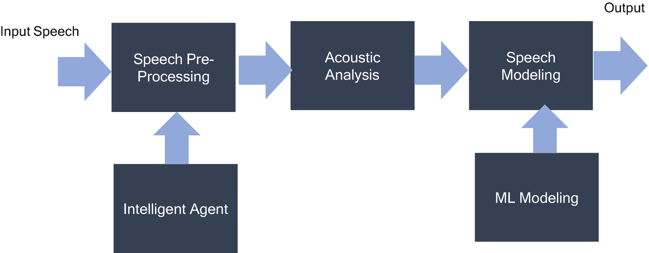

***Figure 5-23***

Speech recognition modules

* *Speech* *preprocessing* : Through the recording tool, the input speech data is stored in WAV format. The components of microservices are as follows:
  1. A.

The external interface to read WAV file, AIFF, AU, or PCM files (either batch or near real-time with event-driven concept).

* 1. B.

Checks the quality, frame size, etc.

* 1. C.

Stores the data into the database and is handled by all kinds of interfaces either batch, event-driven, interfaces, etc.

* *Intelligent agent* : This microservice provides a cognitive capability and recognition capability that communicates in natural language with humans and provides an advisory using machine learning and NLP-like intelligence. It provides a set of services that enables services like NLP, speech to text, and text to speech to make an agent see, hear, speak, convert, understand, and interpret natural methods of communication. There are two components in NLP.
  1. A.

*Natural language understanding*: Mapping the given input in the natural language into useful representations and analyzing the different aspects of the language.

* 1. B.

*Natural language generation*: Producing meaningful phrases and sentences in the form of natural languages like text planning, sentence planning, etc.

* *Acoustic analysis* : This microservice implements feature extraction and is used to extract related information such as pitch, frequency, and environment by using the intelligent agent.
* *Speech modeling*: This microservice generates the models for the speech generation process and provides the end output of text for each voice input with the help of various machine learning models.
* *ML modeling*: This microservice is used to make predictions about data; an algorithm together with the training data generates an ML model.

Figure [5-24](https://learning.oreilly.com/library/view/cloud-native-architecture/9781484272268/html/511610_1_En_5_Chapter.xhtml#Fig24) provides a high-level view of microservice architecture with domain objects and provides flow with events and objects.

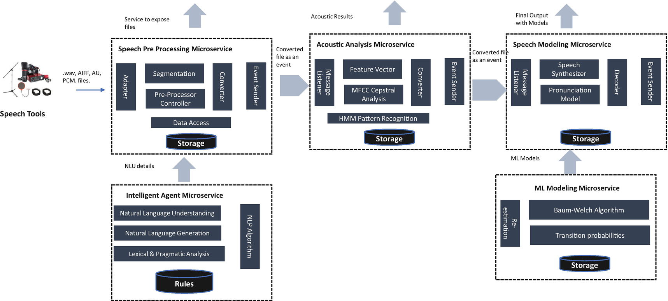

***Figure 5-24***

AI microservices architecture

* *Speech* *preprocessing* *microservices*: This microservice is developed by using Python and components in the microservices that read various types of files and segment raw data speech signals into evenly spaced frames. The frame size can be selected based on rapid transition and enough resolution in frequency. This microservice uses intelligent agent microservices for the NPL process.
* *Intelligent* *agent* *microservices*: These microservices use open source NPL processes like Apache Open NLP (<http://opennlp.apache.org/>), which supports tokenization, sentence segmentation, tagging, chunking, etc. These microservices follow the steps to provide NLP capabilities.
* *Acoustic* *analysis* *microservices*: These microservices extend the details provided by IA microservices along with pitch, frequency, and environment for the statistical analysis. The MFCC (Multi-frequency Cepstral coefficients) Cepstral analysis is a standard technique used for feature extraction. All input files are converted into the MFCC files, which include a list of cepstrum coefficients.
* *Speech modeling microservices*: These microservices use the hidden Markov model (HMM), represented as the simplest dynamic Bayesian network. The speech signals are quasi-stationary and stable for only a short period. The stability of signals can be viewed in the form of states in an HMM topology.
* *ML model microservices*: The ML model microservice is an extension of the speech modeling process with the algorithms split across microservices. This microservice provides the capability of re-estimating the model of the Baum-Welch algorithm; it is used to update the active state with optimal values for HMM parameters. The pronunciation model is used to develop correspondence between different HMMs to form a model for each input. The decoding concatenating subword models are composed into a decoding network.

**Summary**

Software applications today have expectations and requirements that are different from traditional architecture. They have demands related to resilience, time to market, flexibility, failure, self-healing, and reliability.

In this chapter, you learned how microservices support agility in order to keep their software systems closely aligned with the business goals and market opportunities.